HALOALKANES AND HALOARENES
THIS CHAPTER IS DIVIDED INTO 5 PARTS
I) INTRODUCTION AND CLASSIFICATION
II) METHODS OF PREPARATION(MOP)
III) PHYSICAL PROPERTIES
IV) CHEMICAL PROPERTIES
V) USES
------------------------------------------------------------------------------------------------------------------------------------------------
INTRODUCTION AND CLASSIFICATION

Haloalkanes (Alkyl Halides) are chemical compounds formed by replacing one or more hydrogen atoms in an aliphatic hydrocarbon with halogen atoms (Fluorine, Chlorine, Bromine, or Iodine). The halogen atom is attached to an sp3 hybridized carbon atom.

Haloarenes (Aryl Halides) are formed by replacing hydrogen atoms in an aromatic hydrocarbon with halogen atoms. In these compounds, the halogen is directly attached to an sp2 hybridized carbon atom of the aromatic ring.

The general representation of these compounds is R-X for haloalkanes and Ar-X for haloarenes, where X represents the halogen.

NOMENCLATURE SYSTEMS
There are two primary systems for naming these compounds: the Common System and the IUPAC System.

⊙ Common Names:
Haloalkanes are named as Alkyl halides. This involves naming the alkyl group (methyl, ethyl, propyl, etc.) followed by the halide (fluoride, chloride, bromide, iodide). For haloarenes, the common name is Aryl halide.
⊙ IUPAC Names:
Haloalkanes are named as Haloalkanes. The halogen is treated as a substituent (fluoro, chloro, bromo, iodo) followed by the name of the parent alkane chain. For haloarenes, the IUPAC name is Haloarene.

Ex : CH3CH2Cl
Common name - Ethyl chloride
IUPAC name - Chloroethane

Formula | Common Name | IUPAC Name
CH3CH2Cl | Ethyl chloride | Chloroethane
CH3CHCl2 | Ethylidene chloride | 1,1-Dichloroethane
CH2ClCH2Cl | Ethylene dichloride | 1,2-Dichloroethane
CHCl3 | Chloroform | Trichloromethane
CCl4 | Carbon tetrachloride | Tetrachloromethane
C6H5-Cl | Chlorobenzene | Chlorobenzene

CLASSIFICATION
i) On the Basis of Number of Halogen Atoms
Compounds are classified based on how many halogen atoms are present in the molecule:
⊙ Mono-haloalkanes/Mono-haloarenes: Contain only one halogen atom.
Example: CH3CH2X (Ethyl halide/Haloethane).
⊙ Di-haloalkanes/Di-haloarenes: Contain two halogen atoms.
Example: CH2X2 (Methylene halide/Dihalomethane).

NOMENCLATURE OF DIHALIDES
Dihalides have specific naming conventions in the common system based on the relative positions of the two halogen atoms:

Geminal Dihalides (Gem-dihalides):
Both halogen atoms are attached to the same carbon atom. In the common system, these are named as "Alkylidene halides".
Example: CH3CHCl2 is named Ethylidene chloride.

Vicinal Dihalides (Vic-dihalides):
Halogen atoms are attached to two adjacent carbon atoms. In the common system, these are named as "Alkylene dihalides".
Example: CH2BrCH2Br is named Ethylene dibromide.

⊙ Poly-haloalkanes: Contain three or more halogen atoms.
Example: CHCl3 (Chloroform/Trichloromethane) and CCl4 (Carbon tetrachloride/Tetrachloromethane).

ii) Compounds Containing sp3 C-X Bond
a) Alkyl Halides (sp3 C-X):
Classified as Primary (1 degree), Secondary (2 degree), or Tertiary (3 degree) depending on the degree of the carbon atom to which the halogen is attached.
1ᵒ : Halogen on a carbon attached to one other carbon.
2ᵒ : Halogen on a carbon attached to two other carbons.
3ᵒ : Halogen on a carbon attached to three other carbons.
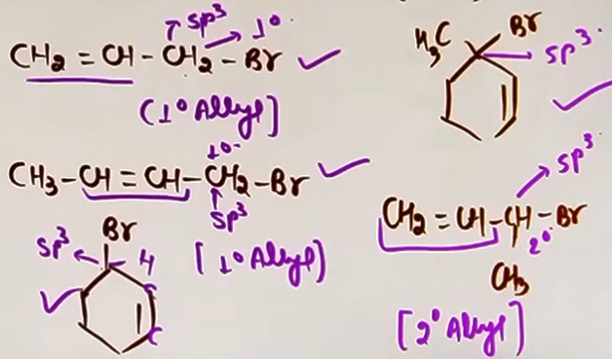
b) Allylic Halides (sp3 C-X):
The halogen is attached to an sp3 hybridized carbon atom which is adjacent to a carbon-carbon double bond (C=C). This carbon is called the allylic carbon.

Benzylic Halides (sp3 C-X): The halogen is attached to an sp3 hybridized carbon atom which is adjacent to an aromatic (benzene) ring.

iii) Compounds Containing sp2 C-X Bond
a) Vinylic Halides (sp2 C-X):
The halogen is attached directly to one of the sp2 hybridized carbon atoms of a carbon-carbon double bond (C=C).
# The sp2 hybridised atom can't be part of an aromatic ring.
b) Aryl Halides (sp2 C-X):
The halogen is attached directly to an sp2 hybridized carbon atom of an aromatic ring.

CONCEPT CONNECTIONS
- Nomenclature of haloalkanes and haloarenes is built upon the basic rules of IUPAC nomenclature learned in Class 11 Hydrocarbons.
- Understanding the sp3 vs sp2 hybridization of the carbon bearing the halogen is critical for predicting reactivity in later sections of the chapter (SN1/SN2 vs ESR/NSR).
- Hybridization Impact: Understanding sp3 vs sp2 attachment is vital because sp2 C-X bonds (Aryl and Vinyl halides) are shorter, stronger, and show partial double bond character due to resonance, making them less reactive toward Nucleophilic Substitution Reactions (NSR).
- Degree and Stability: The degree of the halide (1, 2, or 3) directly dictates the stability of the carbocation formed during SN1 reactions (3 degree is most stable).
- Benzylic/Allylic Reactivity: Although attached to sp3 carbons, allylic and benzylic halides are highly reactive toward both SN1 and SN2 because their transition states or carbocations are stabilized by resonance with the adjacent pi system.

COMMON MISTAKES AND TRAPS
Mistake | Why Students Make It | Correct Approach / Thinking
Confusing Allylic with Vinylic | Both involve C=C bonds. | Allylic is sp3 C next to C=C; Vinylic is X directly on C=C.
Incorrect Common Names for Dihalides | Confusing geminal and vicinal prefixes. | Remember: Geminal = Same carbon (Alkylidene); Vicinal = Adjacent carbons (Alkylene).
Using Aryl/Alkyl names in IUPAC | Habit from common naming. | Use the "Halo-" prefix followed by the parent hydrocarbon name for IUPAC.
Calling Chlorobenzene benzylic | Attached to ring | Benzylic needs an sp3 carbon bridge.

HIGH-YIELD REVISION SHEET
MUST REMEMBER:
- Alkyl Halide = Common Name; Haloalkane = IUPAC Name.
- Gem-dihalide = Alkylidene halide (Halogens on the same C).
- Vic-dihalide = Alkylene dihalide (Halogens on adjacent C).
- Allylic = sp3 C next to C=C.
- Benzylic = sp3 C next to Benzene ring.
- Vinylic = X directly on sp2 C of C=C.
- Aryl = X directly on sp2 C of Benzene ring.
- 1/2/3 degree classification only applies to sp3 hybridized carbons.

--------------------------------------------------------------------------------

NATURE OF C-X BOND
- Halogen atoms are significantly more electronegative than carbon atoms. In any C-X bond, the halogen atom attracts the shared pair of electrons more strongly toward itself.
- Due to this unequal sharing of electrons, the halogen atom develops a partial negative charge (δ-), while the carbon atom develops a partial positive charge (δ+). This specific electronic distribution makes the C-X bond a polar covalent bond.

PERIODIC TRENDS IN BOND PARAMETERS
As we move down the group in the periodic table (from Fluorine to Iodine), the size of the halogen atom increases and electronegativity decreases. This change in size directly affects three major bond parameters: Bond Length, Bond Enthalpy, and Dipole Moment.

A. BOND LENGTH
Bond length is directly proportional to the size of the participating atoms. As the size of the halogen increases down the group, the distance between the carbon nucleus and the halogen nucleus also increases.
Order of Bond Length: C-F < C-Cl < C-Br < C-I.

B. BOND ENTHALPY (BOND STRENGTH)
Bond enthalpy refers to the energy required to break the bond. It is inversely proportional to bond length.
Order of Bond Enthalpy: C-F > C-Cl > C-Br > C-I.

C. DIPOLE MOMENT: THE JEE EXCEPTION {imp}
The dipole moment (μ) is defined by the formula: μ = q * d, where 'q' is the magnitude of the partial charge and 'd' is the bond length (distance).

The Conflict of Factors:
1. Charge Factor (q): Based on electronegativity, Fluorine should create the highest charge, suggesting C-F should have the highest dipole moment.
2. Distance Factor (d): Bond length increases from F to I, which would suggest C-I should have a higher dipole moment if distance were the only factor.

The Experimental Result:
In the case of methyl halides, there is a specific "twist" in the expected order. Although Fluorine is the most electronegative, the bond length of C-Cl is significantly larger than C-F. This increase in distance (d) compensates for the slightly lower charge (q) of Chlorine, making the product (q * d) higher for Methyl chloride.
Correct Order of Dipole Moment: CH3Cl > CH3F > CH3Br > CH3I

[# The carbon in an alkyl halide is "electron-hungry" (electrophilic) because the halogen is constantly pulling electron density away from it. This makes the carbon susceptible to attack by nucleophiles (species looking for positive centers). #]

HIGH-YIELD REVISION SHEET
MUST REMEMBER:
- C-X bond is polar (Carbon = partial positive, Halogen = partial negative).
- Dipole Moment formula: μ = q * d.
- THE Trap: CH3Cl has a higher dipole moment than CH3F.
- Bond Enthalpy order: C-F > C-Cl > C-Br > C-I.
- Bond Length order: C-I > C-Br > C-Cl > C-F.

LAST-MINUTE REVISION POINTS:
- Bond length is all about atomic size.
- Bond enthalpy is the inverse of bond length.
- Dipole moment order is the only trend that is not a perfectly straight line down the group (Cl moves to the front).
- Carbon is electrophilic because it is electron-deficient due to the halogen's pull.

--------------------------------------------------------------------------------

METHODS OF PREPARATION

i) FROM ALCOHOLS:

a) REACTION WITH HX
CORE THEORY
The general reaction is R-OH + HX → R-X + H2O. This involves the substitution of the hydroxyl (-OH) group with a halogen atom (X).

MECHANISM (SN1 FOR 3 DEGREE AND 2 DEGREE)
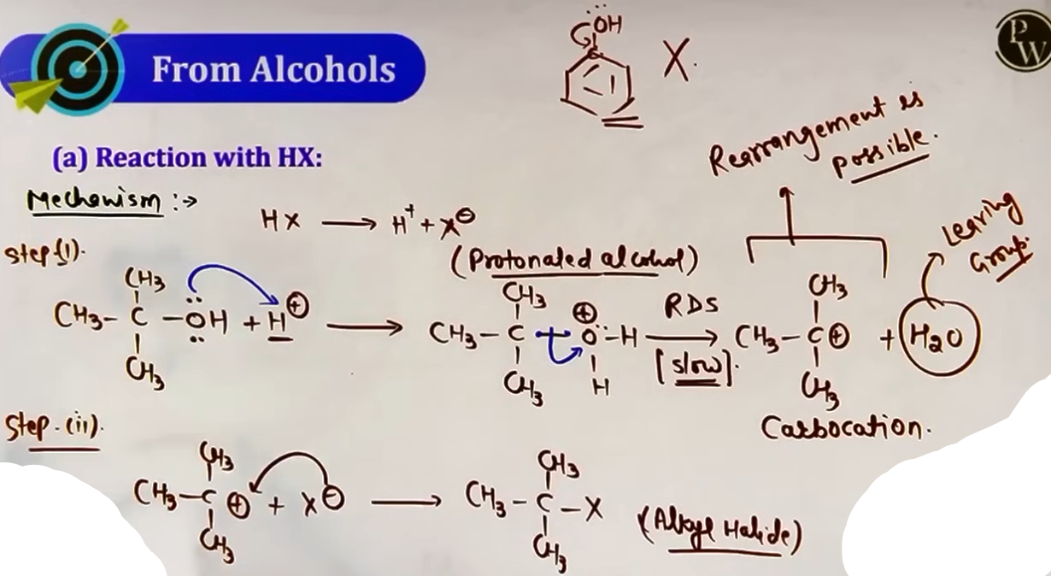
Step 1: Protonation
The alcohol oxygen's lone pair attacks the H+ from HX, forming a protonated alcohol (Oxonium ion/R-OH2+).
# jaise hi oxygen p (+ve) charge aaya uska dimag kharab ho gaya electronegative atoms pe (-ve) charge rakhne ki tendency hoti h (+ve) ke nahi
Step 2: Formation of Carbocation (RDS)
# oxygen carbon bond ka heterolytic fission hota h aur oxygen electron leke water banke nikal jata h usko carbocation banake
Step 3: Attack of Nucleophile
The halide ion (X-) attacks the carbocation to form the final product.

REACTIVITY OF ALCOHOLS
The rate depends on the stability of the carbocation intermediate, since that is the RDS.
∵ 1ᵒ carbocation > 2ᵒ carbocation > 3ᵒ carbocation
∴ Order: 1ᵒ alcohol > 2ᵒ alcohol > 3ᵒ alcohol

REACTIVITY OF HX
Depends on bond strength (bond enthalpy).
∵ HI has the weakest bond and is most reactive.
∴ Order: HI > HBr > HCl.

TEACHER'S INSIGHTS AND TRAPS
- Phenol: Haloarenes cannot be prepared from Phenol and HX because the C-O bond in phenol has partial double-bond character due to resonance, making it very difficult to break.
- Rearrangement: Since a carbocation is formed, hydride shifts, methyl shifts, and ring expansions are possible to reach a more stable carbocation.
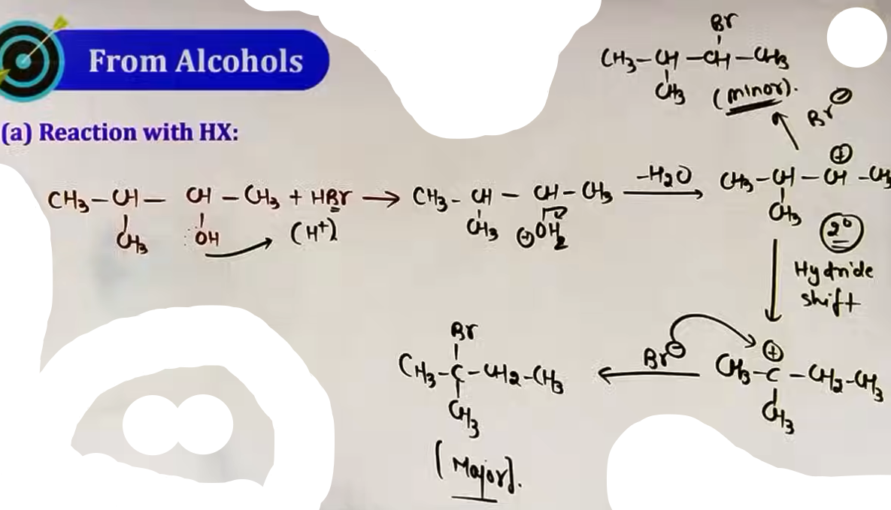
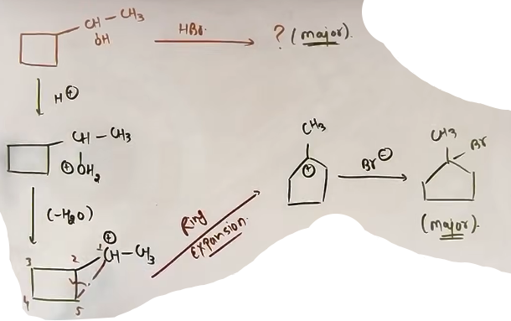
# kai baar HX ki jagah MX {M:metal} diya hoga conc. H2SO4 k sath, kuch alag nahi h same hi reaction h, MX H2SO4 k sath react karke HX aur MHSO4 banayega aur ye HX normally react karega.
- The HI Trap: NaI + H2SO4 cannot be used to prepare R-I because H2SO4 is a strong oxidizing agent. It oxidizes HI back to I2. Use non-oxidizing H3PO4 instead.
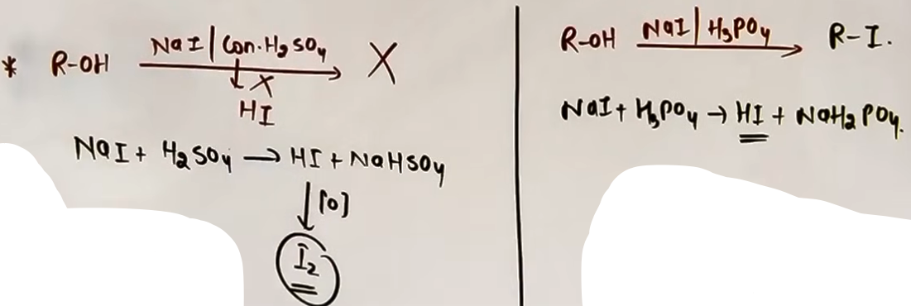

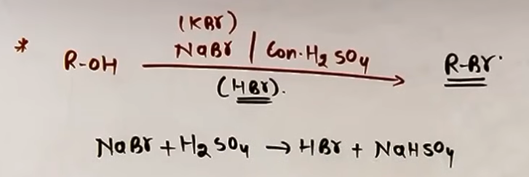
LUCAS TEST
Reagent: Conc. HCl + Anhydrous ZnCl2/AlCl3 {lewis acid}.
Purpose: To distinguish between 1, 2, and 3 degree alcohols.
- 3 Degree Alcohol: White turbidity appears immediately.
- 2 Degree Alcohol: White turbidity appears in 5-10 minutes.
- 1 Degree Alcohol: No turbidity at room temperature; requires heating.
# R-OH + conc.HCL --{anhy. ZnCl2}→ R-Cl + H2O
## R-Cl gives white turbidity.

b) REACTION WITH PHOSPHORUS HALIDES
REACTION WITH PX3 (PCL₃, PBR₃, PI₃)
- Formula: 3 R-OH + PX₃ → 3 R-X + H₃PO₃.
- Mechanism: Sn2. No carbocation is formed, so NO rearrangements occur.
- Stereochemistry: Inversion of configuration (Walden Inversion) occurs because of back-side attack.
# configuration inversion hoga kyunki jaha se leaving group gaya uski ulti jagah naya group laga
- PI3/PBr3 Note: These are not stable and are prepared in situ using Red Phosphorus + X2.

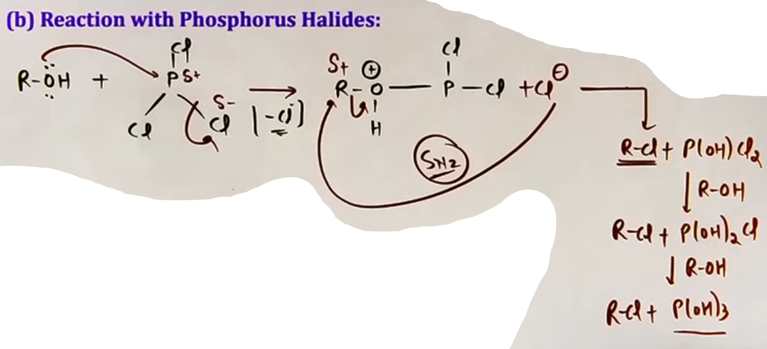

REACTION WITH PCL5
- Formula: R-OH + PCl5 → R-Cl + POCl3 + HCl.
- Key Byproducts: Phosphorus oxychloride (POCl3) and HCl gas.
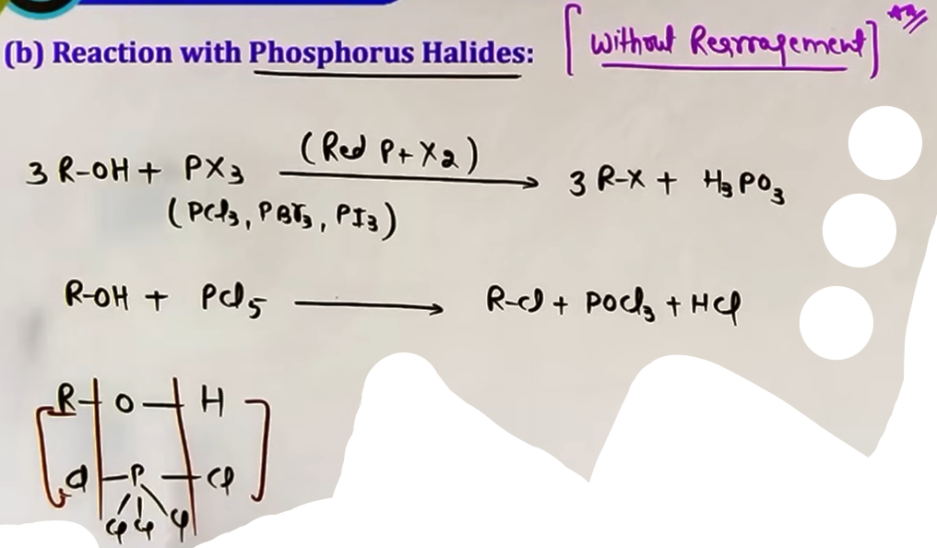
c) DARZEN'S PROCESS (REACTION WITH SOCL2 {Thionyl chloride})
CORE THEORY
Reaction: R-OH + SOCl2 → R-Cl + SO2 + HCl.
Reagent: Thionyl Chloride.
WHY IS IT THE BEST METHOD?
It is considered the most effective way to prepare pure alkyl chlorides because both byproducts (SO2 and HCl) are gases and escape the reaction mixture, leaving behind pure R-Cl.

MECHANISM AND STEREOCHEMISTRY (JEE ADVANCED INSIGHT)
The stereochemical outcome depends on the presence of a base.
- CASE 1: SOCl2 alone (SNi mechanism)
Result: Retention of configuration. The halogen replaces the OH from the same side.
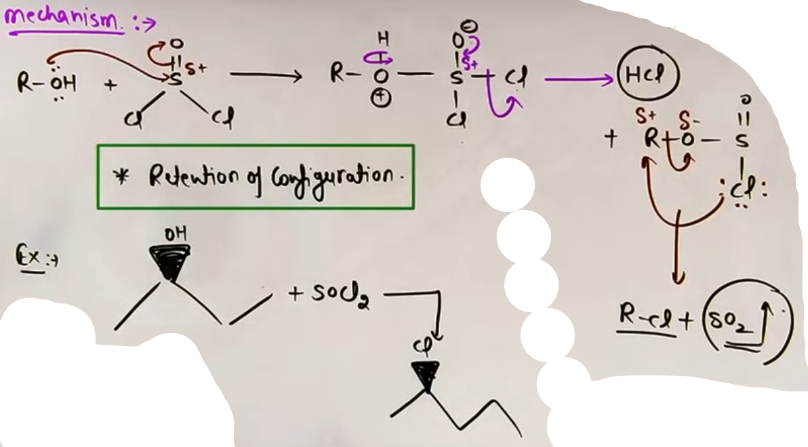
- CASE 2: SOCl2 in the presence of Pyridine (SN2 mechanism)
Result: Inversion of configuration. Pyridine reacts with the byproduct HCl to release free Cl- ions, which attack the carbon from the back side.
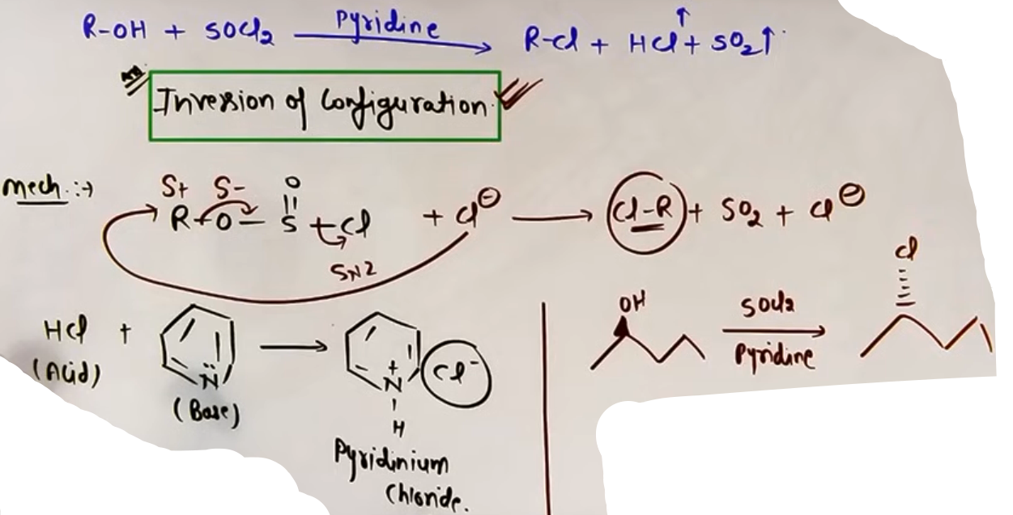
PROBLEM-SOLVING FRAMEWORK
Question Type | Identification | Strategy | Common Mistake
Alcohol + HX | Acid + Alcohol | Form carbocation, check for rearrangement (shift/expansion) | Forgetting rearrangement
Lucas Test | HCl + ZnCl2 | Check time for turbidity (0 min, 5 min, heat) | Confusing 1 deg and 3 deg results
SOCl2 + Base | Pyridine mentioned | Use SN2 logic (Inversion) | Using retention in presence of base
PX3 Products | Red P + Br2/I2 | Direct substitution, no rearrangement | Trying to rearrange the carbon chain

COMMON MISTAKES AND TRAPS
Mistake | Why Students Make It | Correct Approach
Rearranging in PX3/PCl5 | Thinking all alcohol reactions have carbocations | Only HX reactions proceed through carbocations. P-halides are SN2.
Missing Ring Expansion | Overlooking small ring strain | 4-membered rings with adjacent + charge always expand to 5-membered rings.
H2SO4 with NaI | Using it as a source of H+ | H2SO4 is an oxidant. Use H3PO4 for HI preparation.
Ignoring Pyridine | Treating SOCl2 + Pyridine as same as SOCl2 alone | Pyridine changes the mechanism from SNi (retention) to SN2 (inversion).

HIGH-YIELD REVISION SHEET
KEY OBSERVATIONS:
- Reactivity towards HX: Benzylic/Allylic > 3 Deg > 2 Deg > 1 Deg.
- SOCl2 alone = SNi (Retention).
- SOCl2 + Pyridine = SN2 (Inversion).
- Red P + I2 produces PI3 in situ for R-I preparation.
LAST-MINUTE REVISION POINTS:
- Always check for 1,2-hydride or methyl shifts when using HX.
- Ring expansion (4 to 5 or 5 to 6) is a common JEE trap for alcohol + HX.
- Lucas reagent gives immediate results only for 3 degree or stable allylic/benzylic alcohols.
- Gaseous byproducts in Darzen's process are the reason for its efficiency.

--------------------------------------------------------------------------------

ii) MOP FROM ALKANES (FREE RADICAL HALOGENATION)
CORE THEORY
Alkanes react with halogens (Cl2 or Br2) in the presence of UV light or heat (520-670 K) to form haloalkanes. This is a substitution reaction where hydrogen atoms are replaced by halogen atoms.

Mechanism: Free Radical Substitution
Step 1: Initiation - Homolytic fission of the halogen-halogen bond (X-X) by light/heat to form free radicals.
Step 2: Propagation - Halogen radical abstracts a hydrogen from the alkane to form an alkyl radical, which then reacts with another halogen molecule.
Step 3: Termination - Radicals combine to stop the chain.
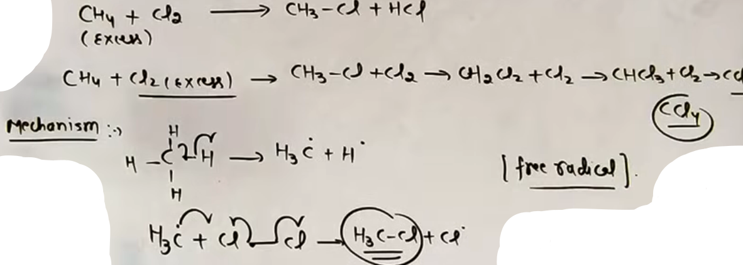
Key Observations:
- Mixture of Products: This method often gives a mixture of mono, di, tri, and poly-haloalkanes if the halogen is in excess.
- Reactivity of Halogens: F2 (explosive) > Cl2 > Br2 > I2 (reversible).
- Reactivity of H-atoms: The ease of replacement of H-atoms follows the stability of free radicals: 3 degree > 2 degree > 1 degree.

Iodination:
Reaction with I2 is reversible because HI formed is a strong reducing agent that reduces R-I back to R-H. To drive the reaction forward, an oxidizing agent like HIO3 or HNO3 is used to destroy HI as it forms.
# HI kam hoga toh La Chatelier's principle se reaction forward jyada proceed karegi kyunki reaction backward reaction karne k liye HI rahega hi nahi.
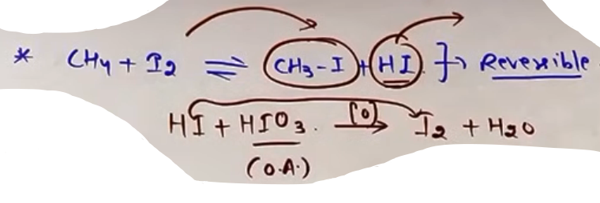
iii) MOP FROM ALKENES (ADDITION REACTIONS)
# Markovnikov boards tak theek h par jee m question galat ho sakte h.
A. ADDITION OF HX (HYDROHALOGENATION)
Alkenes react with HX (HCl, HBr, HI) to form alkyl halides via electrophilic addition.

[ Markovnikov's Rule:
In the addition of HX to an unsymmetrical alkene, the negative part of the reagent (X-) attaches to the carbon atom having the lesser number of hydrogen atoms. ]

Mechanism and Intermediate:
- The reaction proceeds through a Carbocation intermediate.
- Rate Determining Step (RDS): Formation of the carbocation.
- Rearrangement: Since carbocations are formed, 1,2-hydride shifts, 1,2-methyl shifts, or ring expansions occur to form a more stable carbocation before the final attack of the halide ion.
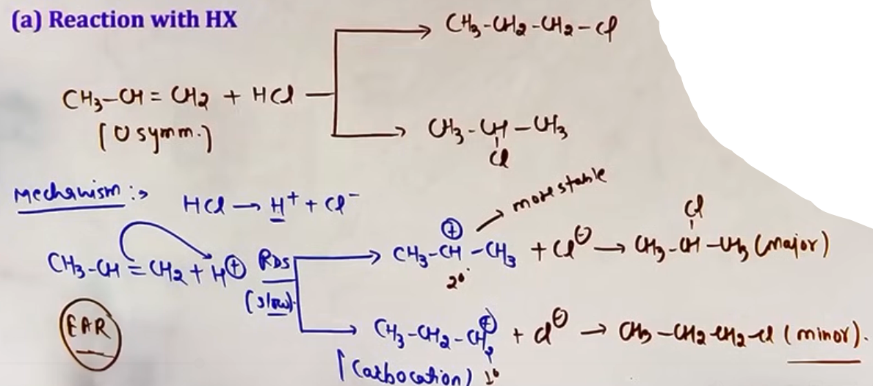
B. PEROXIDE EFFECT (KHARASCH EFFECT)
When HBr is added to an unsymmetrical alkene in the presence of organic peroxides (like benzoyl peroxide), the addition follows Anti-Markovnikov's Rule.

Key Rules:
- Anti-Markovnikov: The Br attaches to the carbon with more hydrogen atoms.
- Specificity: This effect is ONLY observed with HBr. It does not occur with HCl or HI because the steps involved are not both exothermic for those halogens.
- No Rearrangement: Since no carbocation is formed, rearrangements do not occur in the peroxide effect.
- Mechanism: Free Radical Addition (not carbocation).
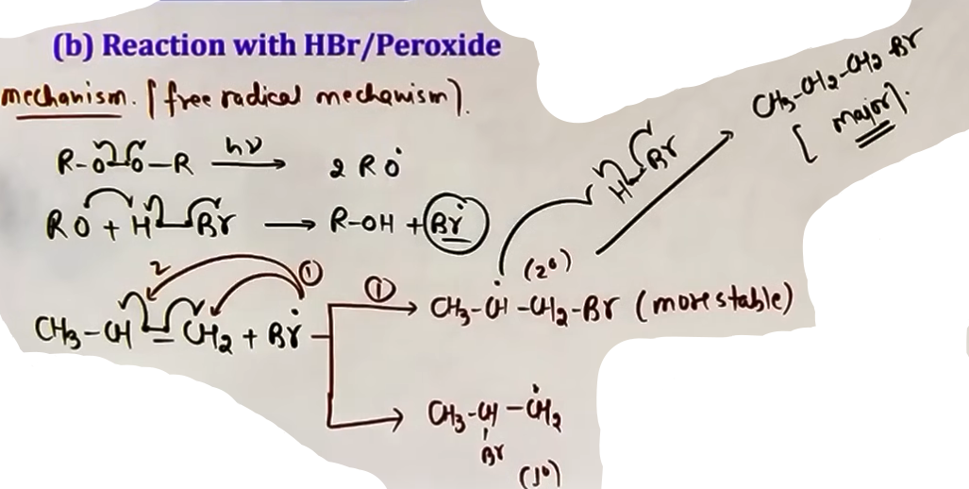
# O-O kafi weak bond hota h

C. ADDITION OF X2 (HALOGENATION)
Addition of Br2 in CCl4 to an alkene results in the formation of Vicinal Dihalides.
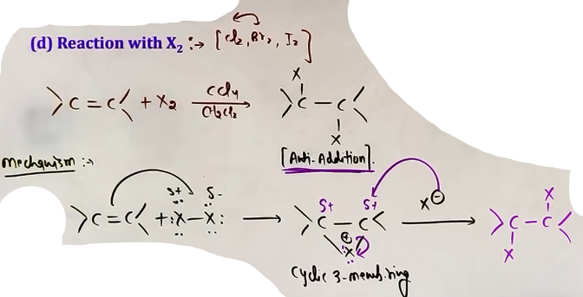
Core Theory:
- Mechanism: Anti-addition. # jo dono halogen lagegenge opposite side m lagenge
- Intermediate: Cyclic Halonium Ion (e.g., cyclic bromonium ion).
- Test for Unsaturation: The reddish-brown color of bromine in CCl4 is discharged (decolorized) when added to an alkene or alkyne. This serves as a laboratory test for the presence of double or triple bonds.

# X2 k sath CCl4 h toh alag product, H2O h toh alag product, high temperature h toh alag product.
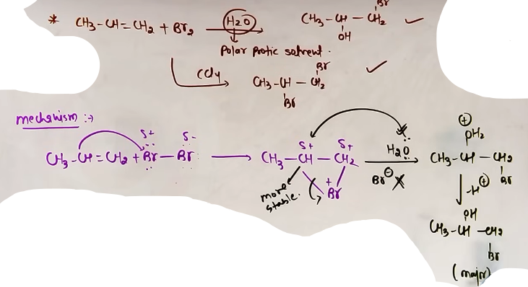

iv) From Alkynes-
- rxn with X2 aur rxn with HX
dono jaise alkenes m thi waise hi bas do baar hongi aur product Markonikov k according.
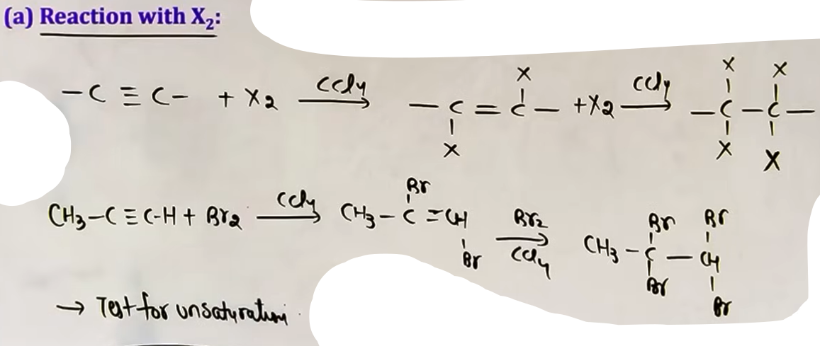

SPECIAL PREPARATION METHOD
ALLYLIC AND BENZYLIC SUBSTITUTION
Halogenation occurs at the allylic or benzylic position (sp3 carbon adjacent to a double bond or benzene ring) under specific conditions.
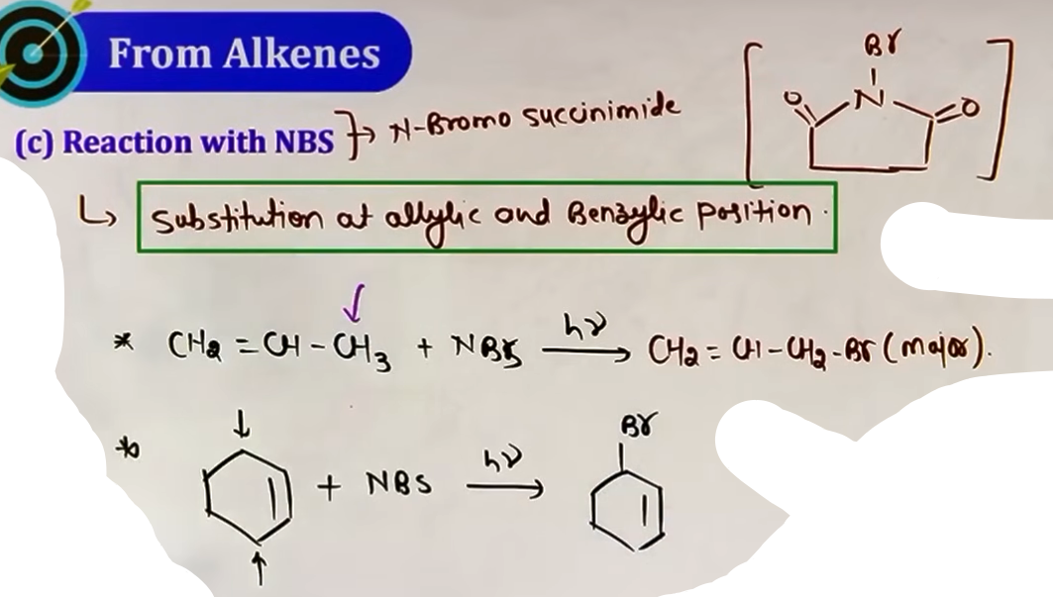
Reagents:
- NBS (N-Bromosuccinimide): Specifically used for allylic or benzylic bromination.
- High Temperature Halogenation: Treating alkenes with Cl2 or Br2 at very high temperatures (approx 700 K) leads to allylic substitution instead of addition.

v) HALOGEN EXCHANGE REACTIONS
Used to prepare alkyl iodides and alkyl fluorides which are difficult to prepare directly.

1. Finkelstein Reaction:
R-X + NaI (in Dry Acetone) -> R-I + NaX.
- R-X is usually R-Cl or R-Br.
- Acetone is used because NaI is soluble in it, but NaCl and NaBr precipitate out, shifting the equilibrium forward (Le Chatelier's Principle).
# Dry isliye kyunki agar water H2O hoga toh wo I- ka solvation kar dega uski mobility ghata dega aur vo dheere dheere move karega toh rate of rxn ghatege.
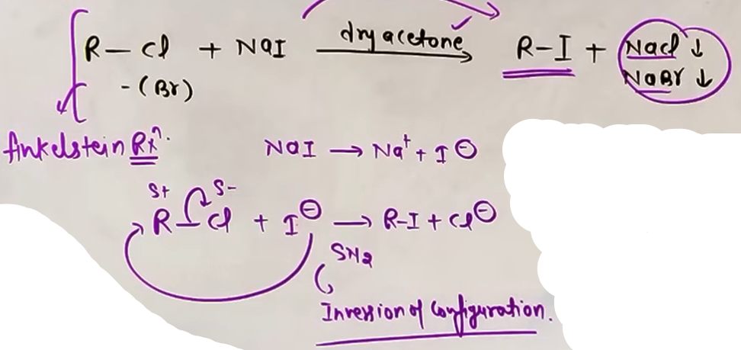

2. Swarts Reaction:
R-X + Metallic Fluoride -> R-F + Metallic Halide.
- Metallic fluorides used: AgF, Hg2F2, CoF2, or SbF3.

vi) From Arenes
- jonsa group laga h vo ortho/para/meta directing jaisa hoga us hisab se product banega
- para product major hota h ortho k comparison m
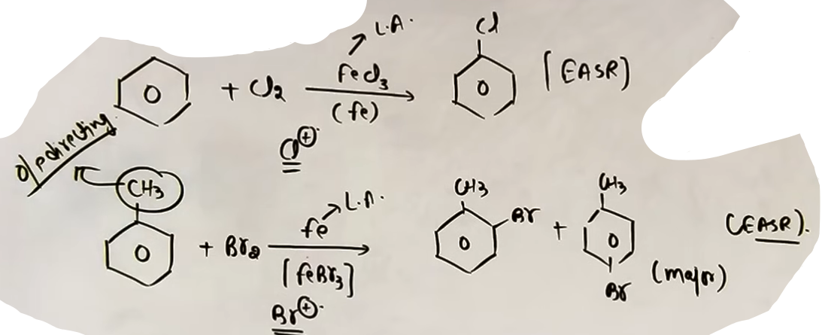
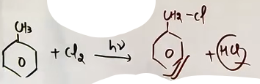
@ photo - halo21
@ photo - halo22 # iska bhi dhyan rakhna

CONCEPT CONNECTIONS
Method | Intermediate | Rule Followed | Rearrangement?
Alkanes + X2/hv | Free Radical | 3 deg > 2 deg > 1 deg | No
Alkenes + HX | Carbocation | Markovnikov | Yes
Alkenes + HBr/Peroxide | Free Radical | Anti-Markovnikov | No
Alkenes + X2/CCl4 | Cyclic Halonium | Anti-addition | No
Allylic (NBS) | Free Radical | Resonance stabilized | Possible

COMMON MISTAKES AND TRAPS
Mistake | Why Students Make It | Correct Approach
Applying Peroxide Effect to HCl | Generalizing "peroxide = anti-Markovnikov" | Remember: It only applies to HBr.
Forgetting shifts in HX addition | Direct addition without carbocation check | Always draw the intermediate carbocation and look for 1,2-shifts.
Using NBS for addition | Confusing with Br2/CCl4 | NBS is for allylic/benzylic substitution, not addition to the double bond. |
Wrong product in Finkelstein | Thinking it makes R-Cl | Finkelstein is specifically for making R-I from R-Cl/Br.

HIGH-YIELD REVISION SHEET
MUST REMEMBER:
- Free Radical Stability: 3 degree > 2 degree > 1 degree.
- Carbocation Stability: 3 degree > 2 degree > 1 degree.
- HBr + Peroxide = Anti-Markovnikov (Free Radical).
- Br2 in CCl4 = Anti-addition (Cyclic Halonium Ion).
- Darzen's Process (from previous topic) remains the best for R-Cl.
- Finkelstein = NaI/Acetone; Swarts = AgF.

LAST-MINUTE REVISION POINTS:
- Ring expansion (4 to 5, 5 to 6) is very common in HX addition to alkenes.
- NBS works through a free radical mechanism at the allylic/benzylic position.
- Allylic halides and benzylic halides are highly reactive due to resonance stabilization of the intermediates.

--------------------------------------------------------------------------------

vii) PREPARATION FROM DIAZONIUM SALTS: CORE THEORY
Aromatic primary amines (like aniline) react with nitrous acid (NaNO2 + HCl) at low temperatures (0 to 5 degrees Celsius) to form diazonium salts. This process is known as Diazotization.

Benzene diazonium chloride (C6H5N2+Cl-) is a key intermediate because the N2 group is an excellent leaving group. This allows for the synthesis of various aryl halides by replacing the diazonium group with a halogen atom.

Conditions and Stability:
- The reaction must be kept between 0-5 degrees Celsius.
- At higher temperatures, diazonium salts are unstable and decompose.
- These salts are generally used immediately after preparation in the reaction mixture.

SANDMEYER REACTION
The Sandmeyer reaction involves the replacement of the diazonium group in a diazonium salt with a chlorine or bromine atom using cuprous salts.

Reagents and Products:
- To prepare Chlorobenzene: Use Cu2Cl2 dissolved in HCl.
- To prepare Bromobenzene: Use Cu2Br2 dissolved in HBr.

The yield of the Sandmeyer reaction is generally better than the Gattermann reaction.

GATTERMANN REACTION
The Gattermann reaction is a modification of the Sandmeyer reaction where copper powder is used instead of cuprous halides.

Reagents and Products:
- To prepare Chlorobenzene: Use Cu powder and HCl.
- To prepare Bromobenzene: Use Cu powder and HBr.

The diazonium group is replaced by the halogen provided by the halogen acid (HCl or HBr) in the presence of the copper catalyst.

BALZ-SCHIEMANN REACTION
This specific reaction is used to prepare aryl fluorides (Fluorobenzene), which cannot be prepared via the standard Sandmeyer or Gattermann methods.

Process:
1. Benzene diazonium chloride is treated with fluoroboric acid (HBF4).
2. This produces diazonium fluoroborate (C6H5N2+BF4-) as a precipitate.
3. The isolated diazonium fluoroborate is then heated to decompose into fluorobenzene, BF3, and N2 gas.

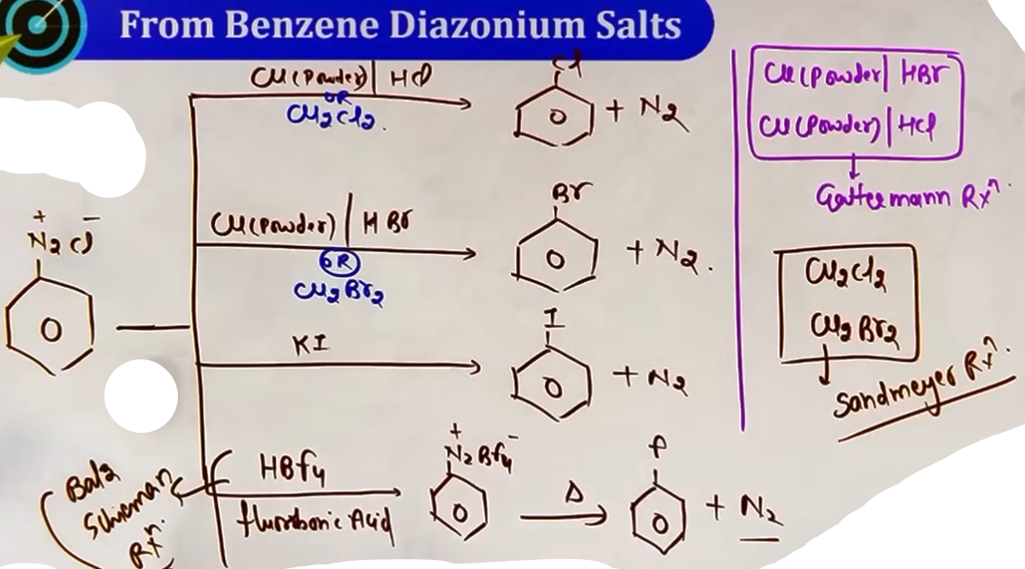

HUNSDIECKER REACTION
The Hunsdiecker reaction is a method used to prepare alkyl or aryl bromides from the silver salts of carboxylic acids.
Core Theory:
- Reagents: Silver salt of carboxylic acid (R-COOAg) and Bromine (Br2) in CCl4.
- Conditions: Reflux/Heat.
- General Reaction: R-COOAg + Br2 -> R-Br + AgBr + CO2.

Mechanism:
- The reaction proceeds through a Free Radical Mechanism.
- It involves decarboxylation (loss of CO2), resulting in a product with one less carbon than the original carboxylic acid salt.
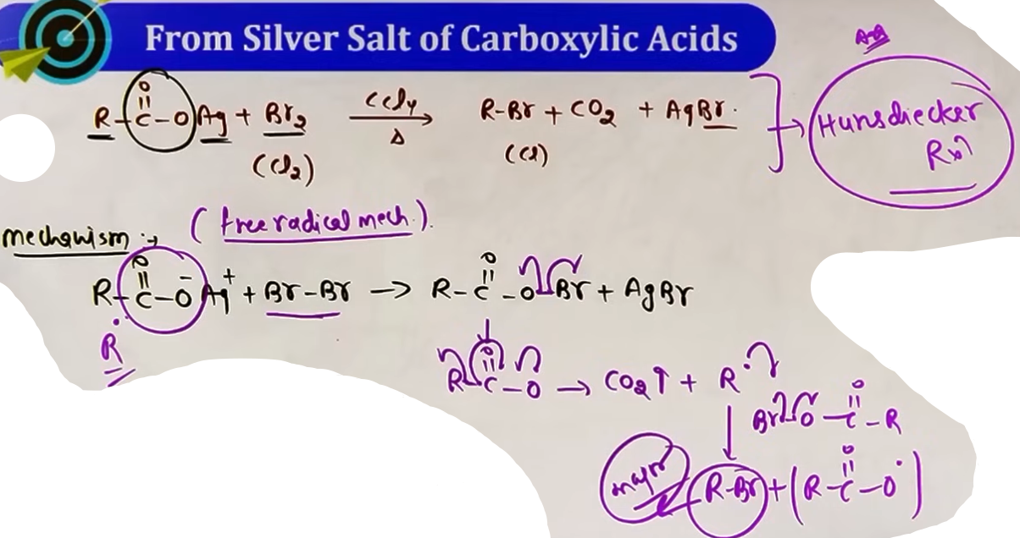
Teacher's Insights:
- Bromine is more reactive in this process than Chlorine because the Br-Br bond is easier to break compared to Cl-Cl.
- If Iodine (I2) is used instead of Bromine, an ester (R-COOR) is formed instead of an alkyl halide. This variation is known as the "Birnbaum-Simonini reaction".

COMPARISON TABLE: PREPARATION METHODS
Method | Reagents | Major Product | Key Feature
Sandmeyer | Cu2X2 / HX | Aryl-X (Cl, Br) | High yield
Gattermann | Cu powder / HX | Aryl-X (Cl, Br) | Modified Sandmeyer
Balz-Schiemann | HBF4 then Heat | Aryl Fluoride | Specific for R-F
KI Reaction | KI + Warmth | Aryl Iodide | No catalyst needed
Hunsdiecker | Ag salt + Br2 | Alkyl/Aryl Bromide | Decarboxylation

HIGH-YIELD REVISION SHEET
MUST REMEMBER FORMULAS:
- Diazotization: C6H5NH2 + NaNO2 + 2HCl (0-5 C) -> C6H5N2+Cl- + NaCl + 2H2O.
- Sandmeyer: C6H5N2+Cl- + Cu2Cl2/HCl -> C6H5Cl + N2.
- Balz-Schiemann: C6H5N2+Cl- + HBF4 -> C6H5N2+BF4- (Heat) -> C6H5F + BF3 + N2.
- Hunsdiecker: R-COOAg + Br2 -> R-Br + AgBr + CO2.

LAST-MINUTE REVISION POINTS:
- N2 is a great leaving group, driving diazonium salt reactions.
- Hunsdiecker reaction is a step-down reaction (reduces carbon chain length by 1).
- Silver salt + I2 = Ester (not R-I).
- Sandmeyer yields are generally higher than Gattermann yields.

--------------------------------------------------------------------------------

PHYSICAL PROPERTIES

- Haloalkanes and haloarenes are polar molecules because of the electronegativity difference between carbon and halogen atoms.
- The physical properties of these compounds are primarily governed by intermolecular forces.
- In alkyl halides, the primary intermolecular force is the dipole-dipole interaction.
- Since these molecules are polar, the negative end of one dipole attracts the positive end of another.
- These interactions are a type of Van der Waals force.
- Van der Waals forces are directly proportional to the molecular mass and the surface area of the molecule.

BOILING POINTS
- The boiling point of a substance is directly proportional to the strength of its intermolecular forces.
- For a given alkyl group, the boiling point increases as the size and mass of the halogen atom increase.
- This is because larger atoms have more electrons, leading to stronger Van der Waals forces.
- As the number of carbon atoms in a straight-chain haloalkane increases, the surface area and the molecular weight increases, which in turn increases the boiling point.
- Higher the branching lower is the surface area and lower the boiling point.

MELTING POINTS
- Melting points depend on both the intermolecular forces and the arrangement of molecules in the crystal lattice.
- In the case of isomeric dihalobenzenes (ortho, meta, and para), the boiling points are nearly the same.
- However, the melting points show a distinct trend where the para-isomer has a significantly higher melting point than the ortho and meta isomers.
- This is due to the high symmetry of the para-isomer.
- Symmetrical molecules fit better into the crystal lattice, leading to stronger packing and requiring more energy to break during melting.

DENSITY
Down the group jane par mass aur volume dono barta h par mass jyada badta h toh down the group jane par desity increse karti h.
RI > RBr > RCl > RF {Density}
CCl4 > CHCl3 > CH2Cl2 > CH3Cl {Density}

SOLUBILITY
- Alkyl halides are only very slightly soluble in water.
- Less energy is released when new attraction are set up between the haloalkanes and the water molecules as these are not as strong as the original hydrogen bonds in water.
- However, haloalkanes tend to dissolve in organic solvents because the new intermolecular attractions between haloalkanes and solvent molecules have much the same strength as the ones being broken in the seperate haloalkane and solvent molecules.

INTUITION AND CONCEPTUAL UNDERSTANDING
- Think of boiling point as the energy needed to pull "sticky" molecules apart.
The "stickiness" comes from the size of the molecule (surface area) and its polarity (dipole moment).
Larger molecules like alkyl iodides are much "stickier" than alkyl fluorides because of their massive surface area and large number of electrons.
- For branching, imagine a long rectangular block (straight chain) versus a sphere (branched).
Long blocks can stack closely together with lots of contact surface, making them hard to pull apart. Spheres only touch at a single point, reducing the contact area and making them much easier to boil.
- For melting points of haloarenes, visualize a puzzle.
The para-isomer is like a perfectly shaped puzzle piece that fits tightly into a box (the crystal lattice).
Because it fits so well, it is much harder to "shake" the molecules out of their solid arrangement compared to the clunky ortho or meta pieces.

FORMULA SHEET
RULES FOR BOILING POINT (BP)
- BP is proportional to Intermolecular Forces.
- BP is proportional to Molecular Mass.
- BP is proportional to Surface Area.
- BP is inversely proportional to Branching (for isomers).

BOILING POINT ORDERS
- Same R group: R-I > R-Br > R-Cl > R-F.
- Same X group: R(long chain)-X > R(short chain)-X.
- Halogenated Methanes: CCl4 > CHCl3 > CH2Cl2 > CH3Cl.

MELTING POINT (MP) ORDER FOR DIHALOBENZENES
- Para > Ortho ≈ meta.

JEE ADVANCED INSIGHTS
Boiling points of dihalobenzenes (ortho, meta, para) are very close to each other, and students should not try to memorize exact differences.
The major distinction in haloarenes is the melting point.
Symmetry is the keyword for para-isomer melting points.
The para-isomer fits more "closely" in the lattice compared to ortho and meta.

--------------------------------------------------------------------------------
SOLVENTS

CORE THEORY OF SOLVENTS
Solvents are substances used to dissolve solutes and provide a medium for chemical reactions. In organic chemistry, particularly in the study of haloalkanes and haloarenes, solvents are classified based on their polarity and their ability to donate protons.

Classification by Polarity:
- Non-Polar Solvents: These are solvents with a dipole moment of zero (mu = 0). They do not have a permanent separation of charge.
- Polar Solvents: These solvents have a dipole moment greater than zero (mu≠0).
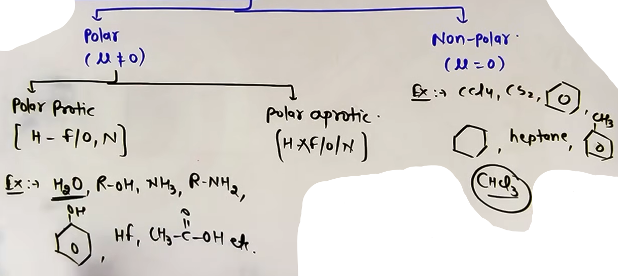

Sub-Classification of Polar Solvents:
- Polar Protic Solvents (PPS): These contain a hydrogen atom bonded to a highly electronegative atom such as Fluorine, Oxygen, or Nitrogen (F, O, N).
- Polar Aprotic Solvents (PAS): These are polar but do not have a hydrogen atom directly bonded to an electronegative atom like F, O, or N.

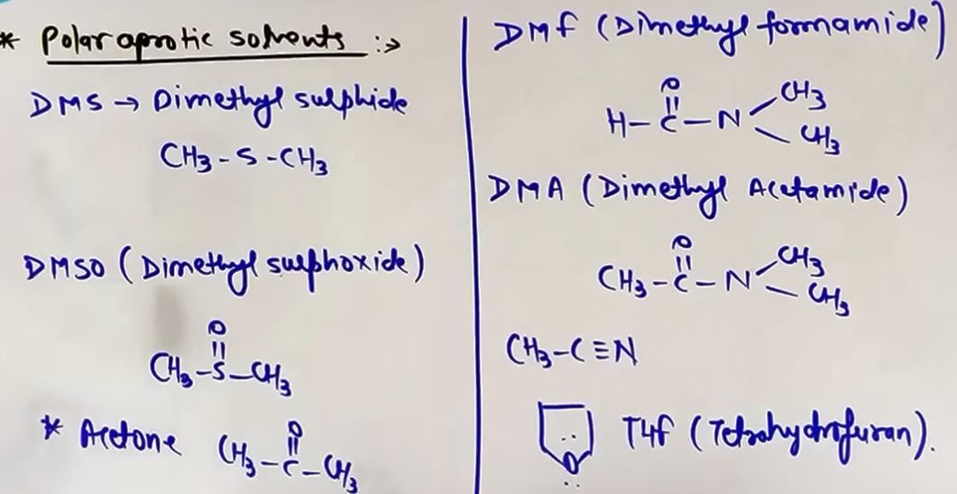
TYPES AND EXAMPLES OF SOLVENTS
Non-Polar Solvents Examples:
- Carbon Tetrachloride (CCl4).
- Carbon Disulfide (CS2).
- Benzene (C6H6).
- Alkanes like Hexane and Heptane.
- Toluene.
- Chloroform (CHCl3) is almost non-polar and sits on the borderline.

Polar Protic Solvents (PPS) Examples:
- Water (H2O) - the most important example for JEE.
- Alcohols (R-OH).
- Ammonia (NH3).
- Acetic Acid (CH3COOH).
- Hydrogen Fluoride (HF).

Polar Aprotic Solvents (PAS) Examples:
- DMSO: Dimethyl Sulfoxide. - Acetone (CH3COCH3).
- DMF: Dimethyl Formamide. - Acetonitrile (CH3CN).
- DMA: Dimethyl Acetamide. - THF: Tetrahydrofuran.
CONCEPT OF SOLVATION
Solvation refers to the interaction between solvent molecules and dissolved ions. The ability to solvate ions varies significantly between protic and aprotic solvents.

Solvation in Polar Protic Solvents (PPS):
- PPS can solvate both cations and anions.
- Cations (like Na+) are solvated by the partial negative end of the solvent dipole (e.g., the Oxygen in H2O) through ion-dipole interactions.
- Anions (like Cl-) are solvated by the partial positive end of the solvent dipole, specifically the hydrogen atoms bonded to electronegative elements.
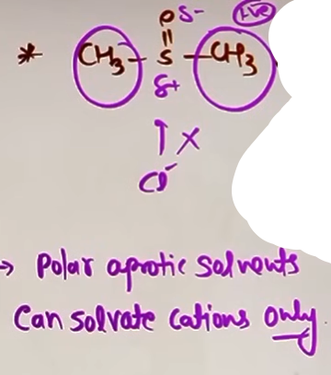
Solvation in Polar Aprotic Solvents (PAS):
- PAS can generally only solvate cations.
- While PAS have a negative center that can interact with cations, their positive center is often sterically hindered by bulky alkyl groups.
- Because the positive center cannot get close to an anion, the anion remains "naked" and highly reactive.

INTUITION AND CONCEPTUAL UNDERSTANDING
- Think of solvents as the "environment" or "mood" of a reaction. A Polar Protic Solvent is like a crowded room where every ion is surrounded and held tight by solvent molecules. This "hugging" of the ions makes them less likely to move and attack other molecules.
- In contrast, a Polar Aprotic Solvent is like a room where only the cations are held back, leaving the anions free to move and strike quickly. This explains why anions are much better nucleophiles in PAS than in PPS.

CONCEPT CONNECTIONS (SN1 VS SN2)
Solvent choice is a primary deciding factor for the mechanism of nucleophilic substitution.

SN1 and Polar Protic Solvents:
- PPS favor the SN1 mechanism.
- They stabilize the carbocation intermediate and the leaving group anion through effective solvation, lowering the energy required for the bond to break.
- High dielectric constant solvents like water help pull the carbon-halogen bond apart.

SN2 and Polar Aprotic Solvents:
- PAS favor the SN2 mechanism.
- Since PAS do not solvate the nucleophilic anion, the anion remains "naked" and maintains high energy to perform a back-side attack.
- Strong nucleophiles are kept reactive in solvents like DMSO or DMF.

HIGH-YIELD REVISION SHEET
MUST REMEMBER:
- PPS (Water, Alcohol) solvate BOTH cations and anions.
- PAS (DMSO, DMF, Acetone) solvate ONLY cations.
- SN1 is favored by PPS.
- SN2 is favored by PAS.
- Anions are "naked" in PAS, making them stronger nucleophiles.

LAST-MINUTE REVISION POINTS:
- mu = 0 means Non-Polar (CCl4, CS2, Benzene).
- H-bond capability = Polar Protic (H2O, NH3, ROH).
- Polar but no H-bonding = Polar Aprotic (DMSO, DMF, Acetone, CH3CN).
- Dielectric constant is highest in PPS like water, making it best for ionizing bonds.

--------------------------------------------------------------------------------
BASICITY AND NUCLEOPHILICITY

Both basicity and nucleophilicity involve species that are electron-rich and have a tendency to donate electron pairs. However, their targets and the nature of their reactions are different.

Basicity:
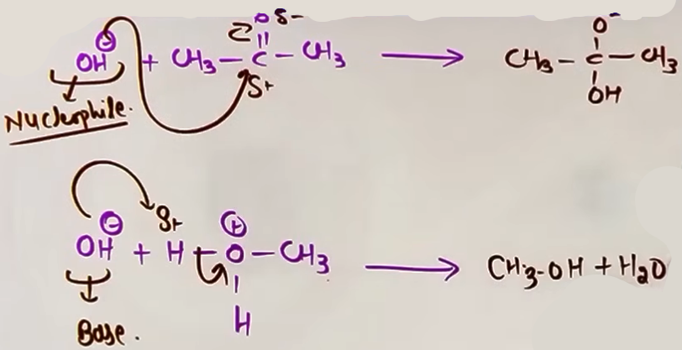
It is the tendency to donate an electron pair specifically to a proton (H+). When a species (like OH-) attacks a hydrogen atom to remove it as H+, it is acting as a base. Basicity is generally a thermodynamic property related to equilibrium constants.

Nucleophilicity:
It is the tendency to donate an electron pair to an electrophilic center other than a proton, usually a carbon atom. When a species attacks a carbon atom (like in an SN2 reaction), it is acting as a nucleophile. Nucleophilicity is a kinetic property related to the rate of reaction.
# basisity nucleophilicity ka hi ek subset h jagah electron donation specially H+ ko ho raha h.

General Rule:
In many cases, the order of basicity and nucleophilicity is the same. If a species is a strong base, it is often a strong nucleophile. However, this relationship breaks down when steric hindrance or solvent effects (solvation) are involved.

FACTORS AFFECTING NUCLEOPHILICITY
1. Charge Density:
Negative species are always better nucleophiles than their neutral counterparts if the attacking atom is the same.
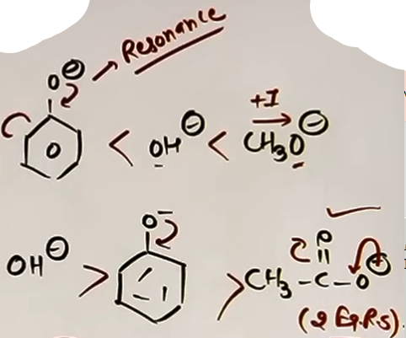
Example: OH- is a better nucleophile than H2O. NH2- is better than NH3.

2. Electronegativity (Periodic Trend):

When comparing atoms in the same period, nucleophilicity is inversely proportional to electronegativity. More electronegative atoms hold their electrons more tightly and are less willing to donate them.
Order: CH3- > NH2- > OH- > F-.

3. Resonance:
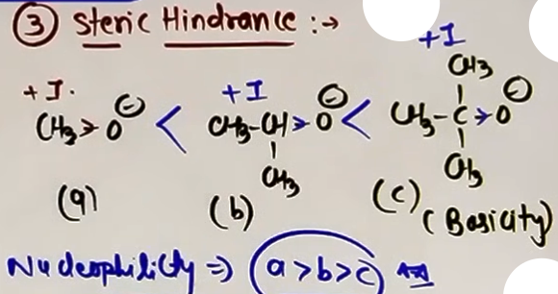
If the negative charge or lone pair is involved in resonance, it is less available for donation, making the species a weaker nucleophile and a weaker base.
Example: Phenoxide ion is a weaker nucleophile than Methoxide ion because the negative charge on Phenoxide is delocalized into the benzene ring.

4. Steric Hindrance:
Bulky groups near the attacking atom significantly decrease nucleophilicity but may not affect basicity as much. A bulky species has difficulty reaching a crowded carbon atom but can easily grab a small, exposed proton (H+).
Example: t-Butoxide is a very strong base but a very poor nucleophile due to its size.

5. Solvent effect (Group trend)
The trend of nucleophilicity down a group (like F-, Cl-, Br-, I-) depends entirely on the solvent used because of solvation.

- In Polar Protic Solvents (PPS) like Water or Alcohol:
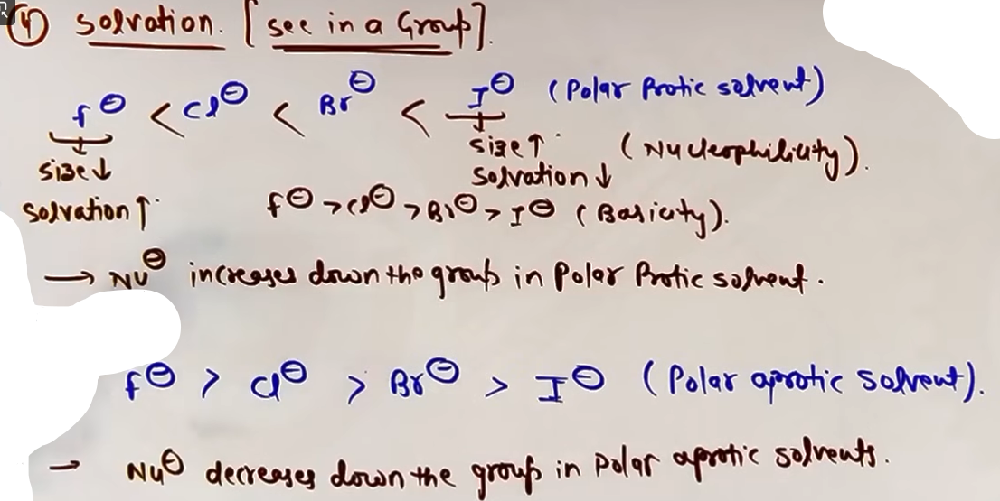
Smaller ions like F- are heavily solvated (surrounded by solvent molecules). This increases their effective size and makes them less reactive. Larger ions like I- are less solvated and can move more freely to attack the carbon.
Nucleophilicity Order in PPS: I- > Br- > Cl- > F-.

- In Polar Aprotic Solvents (PAS) like DMSO or DMF:
These solvents do not solvate anions effectively. Therefore, the anions remain "naked." The reactivity then depends on the charge density/electronegativity.
Nucleophilicity Order in PAS: F- > Cl- > Br- > I-.

FORMULA AND TREND SHEET {General Orders}
- Charge Effect: Anion > Neutral.
- Period Trend: CH3- > NH2- > OH- > F-.
- Group Trend (PPS): I- > Br- > Cl- > F-.
- Group Trend (PAS): F- > Cl- > Br- > I-.
- Steric Effect: Primary > Secondary > Tertiary (for the nucleophile).

CONCEPT CONNECTIONS
Weak bases are good leaving groups. Strong bases are poor leaving groups.
Example: I- is a very weak base, making it an excellent leaving group. OH- is a strong base, making it a very poor leaving group.

JEE ADVANCED INSIGHTS
- Ambident Nucleophiles: These are species with two donor sites (like CN- or NO2-). One site might be more nucleophilic than the other based on charge and electronegativity.
- For example, in KCN (ionic), the carbon attacks because the C-C bond formed is stronger. In AgCN (covalent), the nitrogen lone pair attacks because the carbon is covalently bonded to Silver.
- Bridgehead Carbons: Nucleophiles cannot attack bridgehead carbons in SN2 because back-side attack is geometrically impossible.

COMMON MISTAKES AND TRAPS
Mistake | Why Students Make It | Correct Approach
Ranking F- as top nucleophile in water | Thinking Electronegativity is everything | In water (PPS), F- is too "handicapped" by solvation. I- is best.
Using t-Butoxide for SN2 | It is a strong base | Its bulkiness causes it to favor Elimination (E2) over Substitution (SN2).
Not checking resonance | Focus only on the atom | Resonance-stabilized anions are always weaker nucleophiles.
HIGH-YIELD REVISION SHEET
MUST REMEMBER:
- Nucleophilicity = Speed (Kinetics); Basicity = Stability/Affinity for H+ (Thermodynamics).
- Polar Protic Solvent (PPS): I- is the king of nucleophiles.
- Polar Aprotic Solvent (PAS): F- is the king of nucleophiles.
- Bulky Base = Elimination; Small Nucleophile = Substitution.
- Weak bases are great leaving groups (I-, Cl-, H2O).

LAST-MINUTE REVISION POINTS:
- CH3- is the strongest base and nucleophile in its period.
- DMSO/DMF/Acetone are PAS; they make anions "naked" and fast.
- Steric hindrance kills nucleophilicity but can enhance basicity.
- Resonance (like in Acetate or Phenoxide) makes a nucleophile lazy/weak.

--------------------------------------------------------------------------------
LEAVING GROUP

Definition:
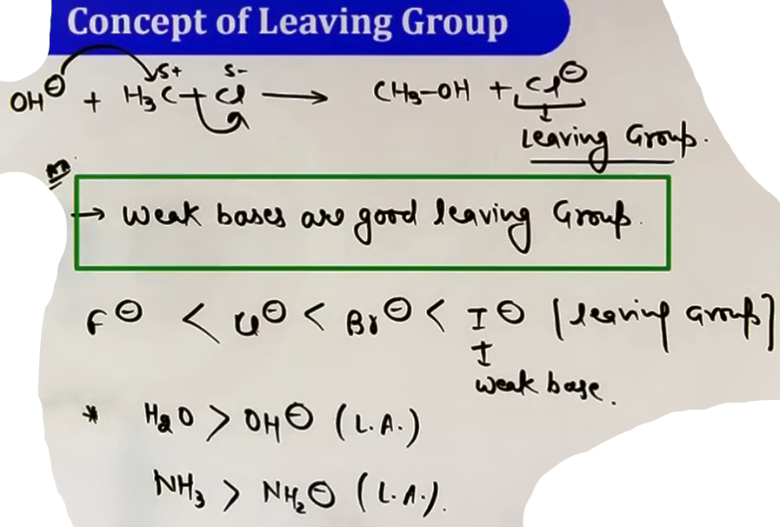
A leaving group is an atom or group of atoms that departs with an electron pair during a chemical reaction, such as a nucleophilic substitution or elimination reaction. In the general reaction {Nu- + R-X -> R-Nu + X-}, the species X- is the leaving group.

Fundamental Rule:
The ability of a group to leave is inversely proportional to its basicity. Weak bases are considered good leaving groups because they are stable after departing and do not easily re-attack the carbon center. Strong bases are poor leaving groups.

Factors Influencing Leaving Ability:
- Basicity: The weaker the base, the better the leaving group.
- Periodic Trends: In a group, leaving ability increases as you move down (I- > Br- > Cl- > F-) because the basicity decreases.
- Neutral vs Ionic: Neutral molecules (like H2O or NH3) are generally much better leaving groups than their corresponding charged anions (OH- or NH2-).
- Resonance: The more a negative charge can be delocalized through resonance, the weaker the base becomes, and therefore, the better it acts as a leaving group.
- Electron Withdrawing Groups (EWG): Groups like -CF3 decrease the electron density (basicity) of the leaving site, improving its ability to leave.

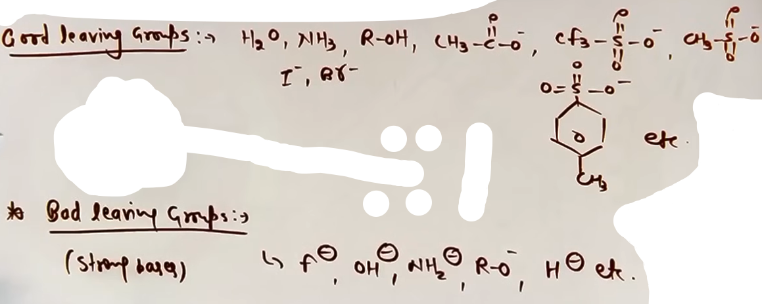

INTUITION AND CONCEPTUAL UNDERSTANDING

Mental Model:
Think of the leaving group as someone leaving a party. If they are very "stable" and "happy" on their own (weak base), they leave easily. If they are "reactive" or "unstable" and want to get back in (strong base), they are a poor leaving group and will try to stop the substitution from happening.

Teacher's Intuitive Explanation:
Stability is the key. A group like I- is a very weak base because its large size allows it to hold a negative charge comfortably. This makes it a "stable" exit. Conversely, OH- is a strong base that is very reactive; it does not want to exist on its own as an anion, so it is a "bad" leaving group.

FORMULA SHEET
Key Relationship:
Leaving Group Ability = 1 / Basicity
Halogen Order:
I- > Br- > Cl- > F-
Resonance Effect:
More Resonance = Weaker Base = Better Leaving Group.

Common Good Leaving Groups:
- H2O (Water).
- N2 (Nitrogen gas). #often called world’s best leaving group
- I- (Iodide).
- R-SO3- (Sulfonate ions like Triflate, Mesylate).

Common Bad Leaving Groups:
- F- (Fluoride).
- OH- (Hydroxide).
- NH2- (Amide ion).
- OR- (Alkoxide ion).
# This is why we protonate alcohols (R-OH to R-OH2+) before trying to remove the oxygen

CONCEPT CONNECTIONS
SN1 and SN2 Mechanisms: Both mechanisms require the breaking of the carbon-halogen bond. Therefore, a better leaving group increases the rate of both SN1 and SN2 reactions.
Elimination Reactions (E1/E2): The leaving group departs along with a beta-hydrogen. Similar to substitution, the rate is faster with better leaving groups (I- > Br- > Cl- > F-).
E1cB Mechanism: This mechanism is a special case that typically occurs when the leaving group is very poor, such as Fluorine (F-), which allows a carbanion to form first.

HIGH-YIELD REVISION SHEET
Must Remember:
- Better LG = Weaker Base.
- Order: I- > Br- > Cl- > F-.
- Neutral molecules (H2O, NH3) are better than anions (OH-, NH2-).
- Gases (N2, CO2, SO2) are superior leaving groups.
- Resonance increases leaving ability.

Last-Minute Revision Points:
- Nitrogen (N2) is the best leaving group.
- Weak bases are good leaving groups; strong bases are bad leaving groups.
- In SN1/SN2/E1/E2, the order of reactivity remains R-I > R-Br > R-Cl > R-F.
- Sulfonates (Triflate, Mesylate) are better than halides.

--------------------------------------------------------------------------------

CHEMICAL PROPERTIES

CORE THEORY OF NUCLEOPHILIC SUBSTITUTION REACTIONS (NSR)
Nucleophilic substitution occurs when a nucleophile (electron-rich species) attacks an electrophilic carbon atom and replaces a leaving group (usually a halogen).

Polarity of C-X Bond:
Halogens are more electronegative than carbon, creating a partial positive charge (δ+) on the carbon and a partial negative charge (δ-) on the halogen. This makes the carbon an electrophilic center susceptible to nucleophilic attack.

i) SN2 MECHANISM (BIMOLECULAR NUCLEOPHILIC SUBSTITUTION)
Mechanism and Kinetics:
- It is a single-step concerted process where bond-making and bond-breaking happen simultaneously.
- Rate = k [R-X][Nucleophile]. It follows second-order kinetics.
- The nucleophile performs a back-side attack on the carbon atom to avoid repulsion from the electron-rich leaving group.
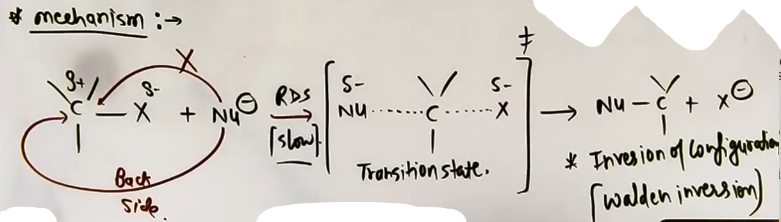
Transition State (TS):
- In the TS, the carbon is partially bonded to both the incoming nucleophile and the outgoing leaving group.
# jaise jaise nucleophile se bond banega waise waise leaving group se bond tutega, dono simultaneously.
- The carbon appears pentavalent in this high-energy {& highly unstable}state.

Stereochemistry:
- Results in 100% Walden Inversion (Inversion of Configuration).
- If the reactant is S-configuration, the product will likely be R-configuration (depending on priority).

Factors Affecting SN2:
- Nature of alkyl halide: Steric hindrance is the most critical factor. Order: Methyl > 1 degree > 2 degree > 3 degree.
- Nucleophile: Requires a strong nucleophile as the rate depends on its concentration/strength.
- Nature of leaving group: jane wala group jitna badiya leaving group utni fast rxn.
- Solvent: Favored by Polar Aprotic Solvents (PAS) like DMSO, DMF, and Acetone because they do not solvate the nucleophile decreasing it's mobility, keeping it reactive.

ii) SN1 MECHANISM (UNIMOLECULAR NUCLEOPHILIC SUBSTITUTION)
Mechanism and Kinetics:
- It is a multi-step process.
- Step 1 (RDS): Heterolytic fission of the C-X bond to form a carbocation intermediate.
- Step 2: Rapid attack of the nucleophile on the carbocation.
- Rate = k [R-X]. The rate is independent of the nucleophile's concentration.
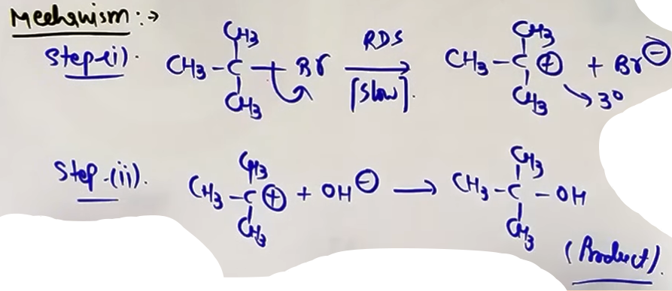
Stereochemistry:
- Results in partial racemization.
- Because the carbocation is planar, the nucleophile can attack from either side.
- Since carbocation is formed rearrangement is possible.
- Inversion is usually slightly greater than retention because the leaving group partially blocks the front side as it departs.

Factors Affecting SN1:
- Nature of Halide: Carbocation stability is the key factor. Order: 3ᵒ> 2ᵒ> 1ᵒ.
- Allylic and benzylic halides are highly reactive via SN1 due to resonance stabilization of the resulting carbocation.
- Nature of leaving group: R-I > R-Br > R-Cl > R-F
- Solvent: Favored by Polar Protic Solvents (PPS) like Water and Alcohol, which stabilize the carbocation and the leaving group anion through solvation.

[ Solvolysis :-
Solvent molecules acts as nucleophiles.
# is particular example p do intermediate bane. ]
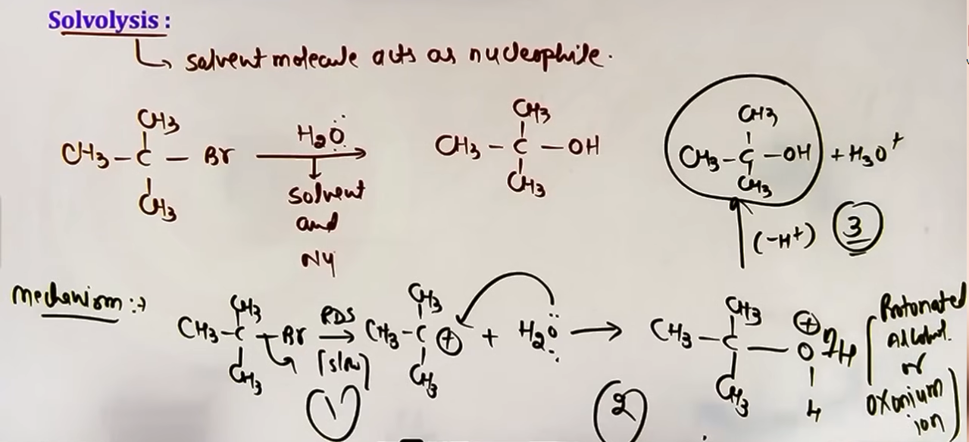

# jitne intermediates usse ek jyada transition states.

vinylic and aryl halides do not undergo nucleophilic substitution under normal condition, due to partial double bond character on C-X bond making it harder to break.

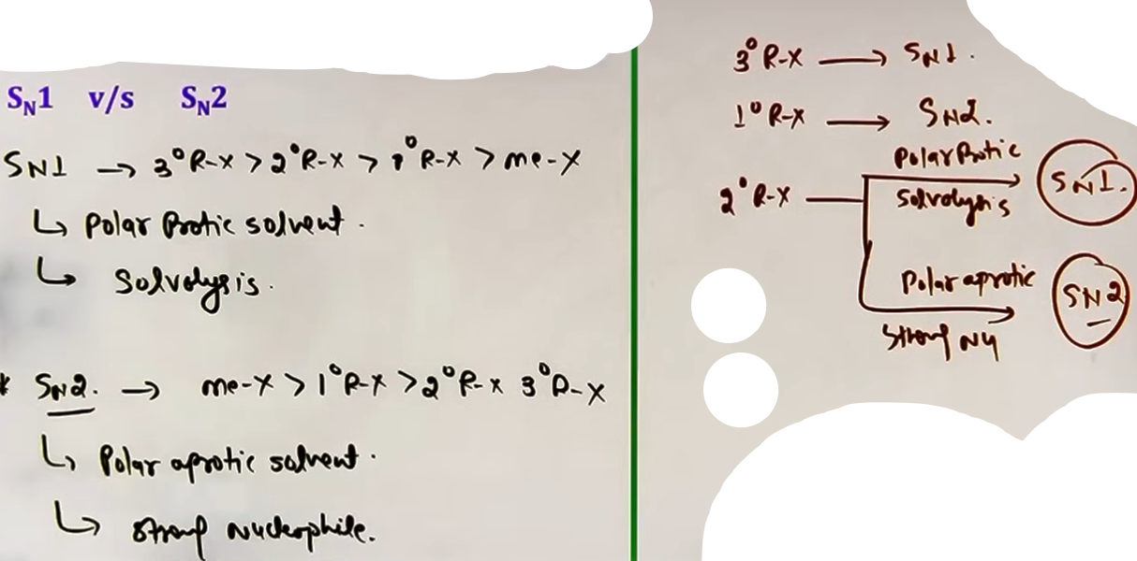
# kaha Sn1 aur kaha Sn2 reaction hogi :-
# solvolysis mil gaya toh pakka Sn1
# polar aprotic mil gaya toh pakka Sn2

iii) SNi MECHANISM
#SOCl2 alone (SNi mechanism)
Result: Retention of configuration.
~@ photo - halo10

AMBIDENT NUCLEOPHILES
Ambident nucleophiles have two donor sites but use only one at a time.
Cyanide (CN⁻):
- Reaction with KCN: Produces Alkyl Cyanide (R-CN) because the C-C bond is more stable.
- Reaction with AgCN: Produces Alkyl Isocyanide (R-NC) because the carbon is covalently bonded to Ag, leaving only the Nitrogen lone pair for attack.
Nitrite (NO2⁻):
- Reaction with KNO2: Produces Alkyl Nitrite (R-ONO) through Oxygen attack.
- Reaction with AgNO2: Produces Nitroalkane (R-NO2) through Nitrogen attack.

FORMULA SHEET
Kinetics:
- SN2 Rate = k [RX][Nu] (Order = 2)
- SN1 Rate = k [RX] (Order = 1)
Reactivity Orders:
- SN2: Methyl > 1 deg > 2 deg > 3 deg
- SN1: 3 deg > 2 deg > 1 deg
- Leaving Group: R-I > R-Br > R-Cl > R-F

PROBLEM-SOLVING FRAMEWORK
Question Type | Identification Clues | Approach / Strategy | Common Mistakes
Predict SN1/SN2 | Substrate degree, solvent | 1 deg = SN2; 3 deg = SN1; 2 deg = Check solvent (PAS=SN2, PPS=SN1). | Ignoring the solvent.
Major Product | KCN vs AgCN | KCN gives R-CN; AgCN gives R-NC. | Forgetting AgCN is covalent.
SN1 Reactivity | Carbocation stability | Check for resonance (Allylic/Benzylic) and degree. | Forgetting rearrangements.
Aryl Reactivity | -NO2 groups present | More EWG at Ortho/Para = faster reaction. | Thinking Meta helps significantly.

JEE ADVANCED INSIGHTS
- Bridgehead Halides: Halogens at bridgehead positions are inert to both SN1 and SN2 because the carbocation cannot be planar and back-side attack is blocked.
- Solvolysis: When the solvent (like water) acts as the nucleophile, it is typically an SN1 process.
- Stereochemical Outcome of SN1: It is never 100 percent racemic; inversion always predominates slightly over retention.

HIGH-YIELD REVISION SHEET
Must Remember:
- SN2 = One step, Inversion, PAS favored, Methyl > 1 > 2.
- SN1 = Two steps, Racemization, PPS favored, 3 > 2 > 1.
- KCN = Cyanide; AgCN = Isocyanide.
- AgNO2 = Nitro; KNO2 = Nitrite.
- Strongest NSR reactivity for both SN1/SN2 is R-I.
Last-Minute Revision Points:
- Check for ring expansion in SN1 (4 to 5 or 5 to 6 membered rings).
- 1 degree Benzylic/Allylic halides react via SN1 despite being primary because the carbocation is resonance-stabilized.
- Dow's Process: Industrial phenol production using extreme conditions for aryl halide NSR.

--------------------------------------------------------------------------------

iv) ELIMINATION REACTION
Elimination reactions involve the removal of atoms or groups from a molecule without being replaced by other groups. In the context of haloalkanes, this usually means the removal of a halogen (X) from the alpha-carbon and a hydrogen (H) from the beta-carbon, resulting in the formation of a double bond (alkene).
This process is known as Dehydrohalogenation or Beta-elimination (also called 1,2-elimination) because the groups are removed from adjacent carbon atoms.

There are three main mechanisms for elimination:
- E2 (Bimolecular Elimination): Single-step concerted process.
- E1 (Unimolecular Elimination): Two-step process involving a carbocation.
- E1cB (Unimolecular Elimination Conjugate Base): Two-step process involving a carbanion.

A. E2 MECHANISM (BIMOLECULAR ELIMINATION)
Mechanism: A single-step concerted process where a strong base removes a beta-proton simultaneously as the leaving group departs. Both bond-making and bond-breaking happen at once.
Reagents: Requires a strong base like Alcoholic KOH (C2H5OH + KOH) or Sodium Ethoxide (NaOC2H5).
Transition State: The molecule passes through a high-energy transition state where the H and X are partially removed.
Kinetics: Rate = k [R-X][Base]. It follows second-order kinetics and has a molecularity of 2.
Reactivity Order: 3ᵒ > 2ᵒ > 1ᵒ. This is because 3ᵒ halides form more substituted {more ∝-hydrogen} and therefore more stable alkenes.
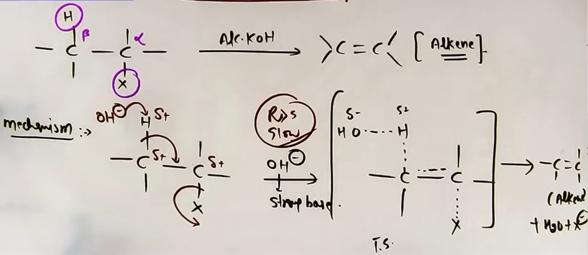

STEREOCHEMISTRY (ANTI-PERIPLANAR REQUIREMENT)
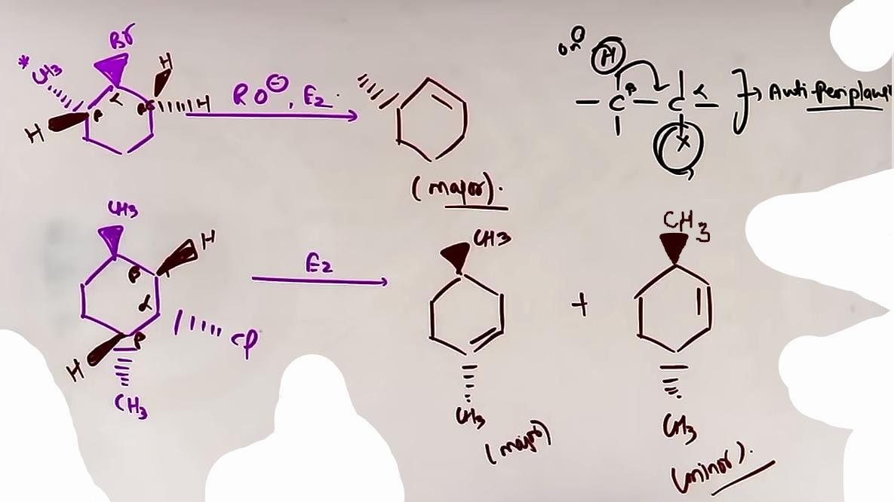
For E2 to occur, the hydrogen being removed and the leaving group (halogen) must be in an anti-periplanar geometry (180 degrees apart). This ensures the electron density from the C-H bond can effectively overlap to form the new pi bond.
In cyclohexane rings, this means the H and X must be trans-diaxial to each other.

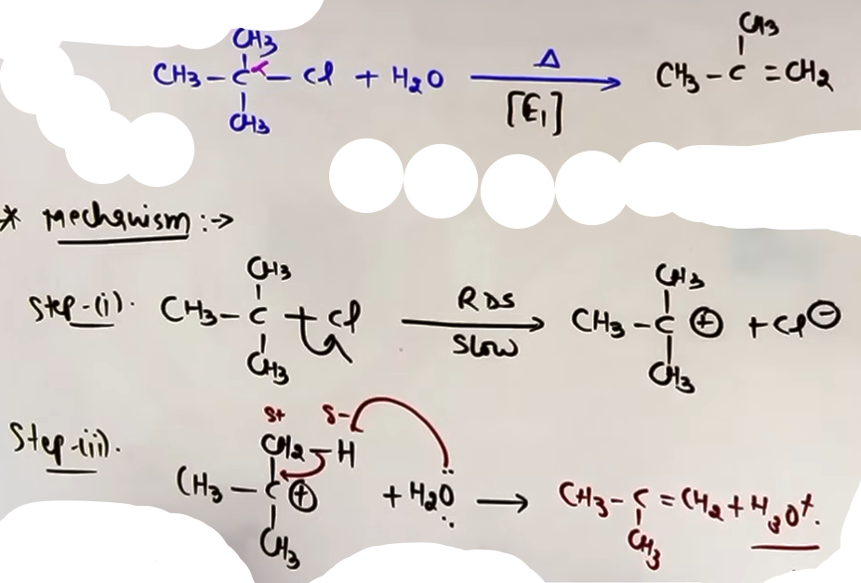
B. E1 MECHANISM (UNIMOLECULAR ELIMINATION)
Mechanism: Two-step process.
Step 1 (RDS): Heterolytic fission of the C-X bond to form a carbocation intermediate.
Step 2: A weak base removes a beta-proton from the carbocation to form an alkene.
Reagents: Favored by weak bases and high temperature (e.g., H2O + Heat or Ethanol + Heat).
Kinetics: Rate = k[R-X]. It follows first-order kinetics; the base concentration does not affect the rate.
Rearrangement: Since a carbocation is formed, rearrangements (hydride shifts, methyl shifts, or ring expansions) are highly possible before the final elimination.
Reactivity Order: 3 degree > 2 degree > 1 degree (following carbocation stability).

C. E1CB MECHANISM (CONJUGATE BASE)
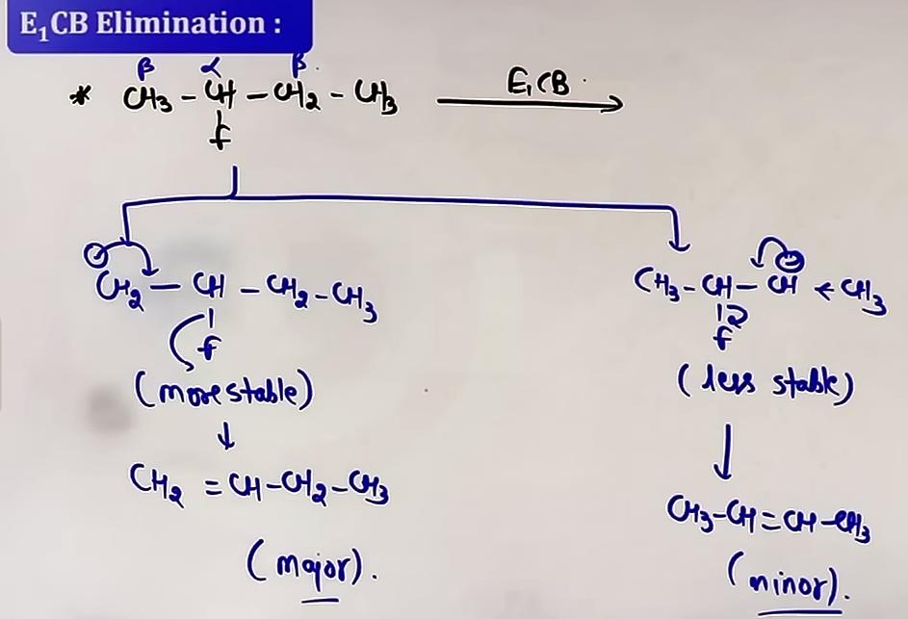
Mechanism: Two-step process via a carbanion.
Step 1: A base removes an acidic beta-hydrogen to form a carbanion (conjugate base).
Step 2 (RDS): The carbanion expels a poor leaving group to form the alkene.
Conditions: Occurs when the leaving group is very poor (like Fluorine) and the beta-hydrogen is relatively acidic.
Major Product: In E1cB, the major product is determined by the stability of the carbanion intermediate rather than the alkene.
# substitution aur elimination dono sath sath chalti hai jahan substitution se major product aa raha hoga waha elimination se minor product bhi aa raha hoga & vice-versa, jiski favourable condition mil jaye uske according major product mil jatega.

♔ High temp. Favours elimination rxn. {main deciding factor}
♔ Strong base Favours elimination rxn.

REGIOSELECTIVITY: SAYTZEFF VS HOFMANN”=
» SAYTZEFF (ZAITSEV) RULE # more substituted alkene
“Generally”, the more substituted (more stable) alkene is the major product.
Example: 2-bromobutane with alcoholic KOH gives But-2-ene as the major product because it is more substituted (6 alpha-hydrogens) compared to But-1-ene (2 alpha-hydrogens).
» HOFMANN RULE # lesser substituted alkene
The less substituted alkene becomes the major product under specific conditions:
- When a bulky base (like Potassium t-butoxide) is used, as it cannot easily reach the more hindered internal hydrogens.
- When the leaving group is a very poor one (like F-) in E1cB.

SPECIAL CASE: RESONANCE
If an elimination can produce an alkene that is in resonance (conjugation) with a benzene ring or another double bond, that product will be major even if it is less substituted, because resonance is a more powerful stabilizing factor than hyperconjugation.

SUBSTITUTION VS ELIMINATION FRAMEWORK
Condition | Favors Substitution (SN) | Favors Elimination (E)
Temperature | Low Temperature | High Temperature
Base/Nu | Weak Base / Nucleophile | Strong/Bulky Base
Reagent | Aqueous KOH (Substitution) | Alcoholic KOH (Elimination)
Substrate | 1 degree Alkyl Halide | 3 degree Alkyl Halide

HIGH-YIELD REVISION SHEET
MUST REMEMBER:
- E2 is single-step (concerted); E1 is two-step (carbocation).
- High Temperature and Strong Base favor Elimination.
- Saytzeff Product = More substituted alkene (Major with small bases).
- Hofmann Product = Less substituted alkene (Major with bulky bases or poor LG).
- E2 requires Anti-periplanar geometry (H and X at 180 degrees).
- Reactivity for E1 and E2: 3 degree > 2 degree > 1 degree.
- Reactivity of halides: R-I > R-Br > R-Cl > R-F.

LAST-MINUTE REVISION POINTS:
- Alcoholic KOH = Elimination; Aqueous KOH = Substitution.
- 3 degree halide + Strong Base = E2 (Alkene major, SN2 blocked).
- In E1, always check for 1,2-hydride or 1,2-methyl shifts to stabilize the carbocation.
- 4-membered rings often undergo ring expansion to 5-membered rings during E1/SN1.
- Bridgehead halides are inert to elimination because they cannot form a planar alkene.

--------------------------------------------------------------------------------

v) REACTION WITH METALS
Reaction with metals leads to the formation of Organometallic compounds, which are defined as substances containing at least one direct Metal-Carbon bond.

A. FORMATION OF GRIGNARD REAGENT
Alkyl halides (R-X) react with Magnesium (Mg) metal in the presence of Dry Ether to form Alkyl Magnesium Halide (R-Mg-X), commonly known as the Grignard Reagent.
The reactivity of halides for this reaction follows the order: R-I > R-Br > R-Cl > R-F, because the C-I bond is the easiest to break.

B. NATURE OF THE GRIGNARD BOND
Carbon-Magnesium bond h toh covalent but highly polar, toh vo R- aur MgX+ ki tarah hi bahave karta h aur R- k bhayankar base hone ki kahaniya toh dur-dur tak prachalit h, tabhi grignard reagent k formation m “dry” ether lete h kyunki agar pani{weak acid} ke ek boond bhi hogi toh vo usse react kar jayega.
R-MgX + H2O -> R-H + Mg(OH)X

C. REACTION WITH ACIDIC HYDROGEN
Because the Grignard reagent is an extremely strong base, it reacts instantly with any source of acidic hydrogen to produce an alkane (R-H).
Sources include Water (H2O), Alcohols (R-OH), Ammonia (NH3), Amines, and even weak acids like terminal Alkynes (R-C≡C-H).

D. WURTZ REACTION {Imp}
Two molecules of alkyl halide react with Sodium (Na) metal in Dry Ether to form a higher alkane (R-R) with double the number of carbons.
This is primarily used for the synthesis of symmetrical alkanes.
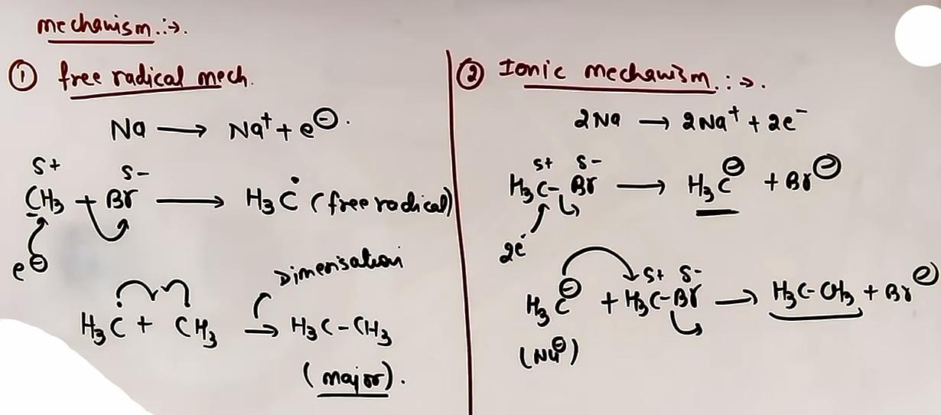
R-X + 2Na + X-R ->{dry ether} R-R +2NaX
{R-X ⇒ 1ᵒ✓, 2ᵒ✓, 3ᵒ✕}
# (CH3)C- tagra nucleophile h par bulky h pehle wali rxn n kafi steric hinderance hoga isliye dusri rxn preferrable hogi. # ispe PYQ aaya h
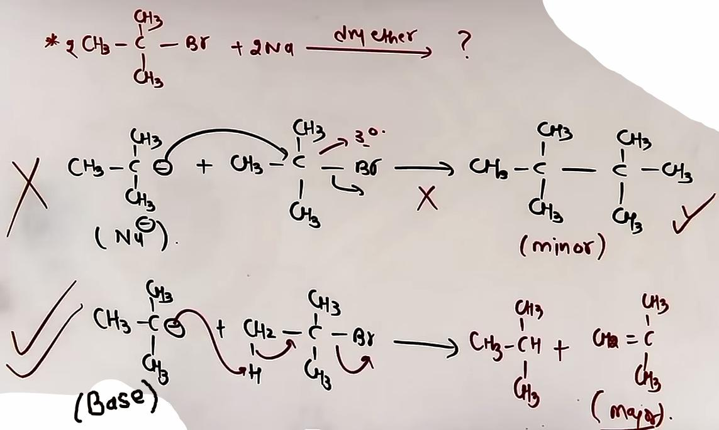

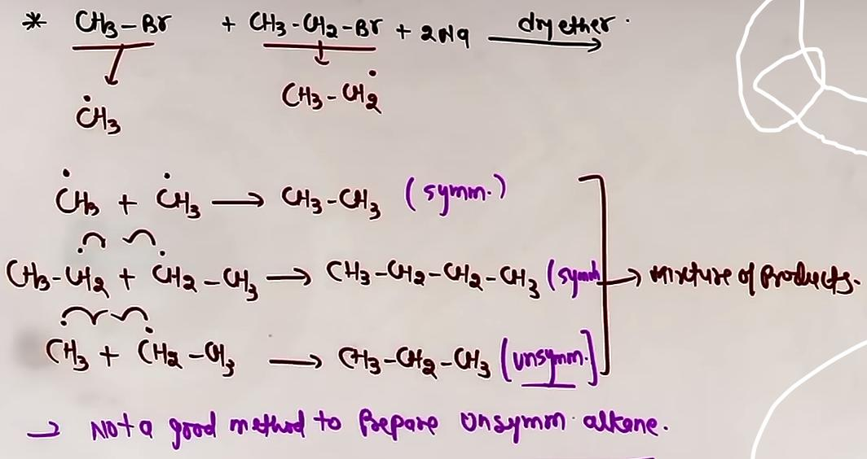Agar alag alag haloalkanes liye toh?
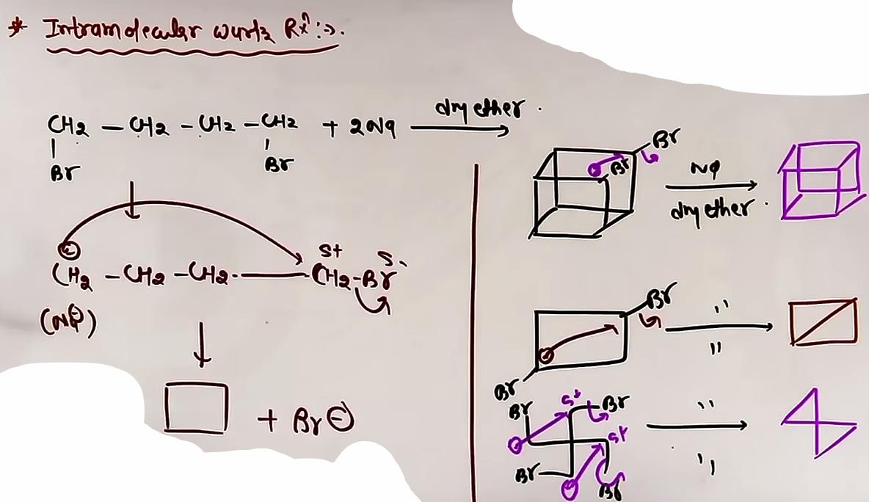Figure 1: Intramolecular wurtx rxn
E. WURTZ-FITTIG AND FITTIG REACTIONS
Wurtz-Fittig Reaction: A mixture of an alkyl halide and an aryl halide reacts with Sodium in Dry Ether to give an alkyl-benzene.
Fittig Reaction: Two molecules of aryl halide react with Sodium in Dry Ether to produce Biphenyl.

FORMULA SHEET
GRIGNARD FORMATION:
R-X + Mg (Dry Ether) -> R-Mg-X
GRIGNARD TO ALKANE:
R-Mg-X + H-OH -> R-H + Mg(OH)X
R-Mg-X + D-OD -> R-D + Mg(OD)X (Used to introduce Deuterium)
WURTZ REACTION:
2 R-X + 2 Na (Dry Ether) -> R-R + 2 NaX
WURTZ-FITTIG REACTION:
Aryl-X + R-X + 2 Na (Dry Ether) -> Aryl-R + 2 NaX
FITTIG REACTION:
2 Aryl-X + 2 Na (Dry Ether) -> Biphenyl + 2 NaX

PROBLEM-SOLVING FRAMEWORK
Question Type | Identification Clues | Approach / Strategy | Common Mistakes
Grignard + H2O | Mg/Ether then H2O | Replace the X with H to form the alkane. | Forgetting that R becomes R-H.
Wurtz Product | Na/Dry Ether + R-X | Dimerize the R-group (join two R groups). | Forgetting Na/Ether is for Wurtz.
Mixture Yield | Two different R-X | Predict R1-R1, R2-R2, and R1-R2. | Thinking only one product forms.
3-Deg Wurtz | Tertiary R-X + Na | Predict an Alkene, not a dimer. | Attempting to dimerize 3-deg R-X.

JEE ADVANCED INSIGHTS
- Wurtz with 3-Degree Halides: If a 3-degree alkyl halide is used in a Wurtz reaction, the major product is an Alkene (via elimination) rather than a dimer. This is because the bulky 3-degree carbanion acts as a base instead of a nucleophile.
- Wurtz Mechanism: Two pathways exist—the Free Radical Mechanism (generating R radicals) and the Ionic Mechanism (generating R-minus carbanions).
- Benzyl/Allyl Reactivity: These halides react very fast in Wurtz reactions due to the stability of the intermediate radicals/carbanions.

HIGH-YIELD REVISION SHEET
MUST REMEMBER:
- Grignard Reagent (R-MgX) is a strong base and nucleophile.
- Dry Ether is essential to prevent reaction with moisture.
- Wurtz Reaction: 2 R-X + Na -> R-R (Dimerization).
- Fittig Reaction: 2 Aryl-X + Na -> Biphenyl.
- Wurtz-Fittig: Aryl-X + Alkyl-X + Na -> Alkyl Benzene.
- Methane cannot be prepared by Wurtz reaction.

LAST-MINUTE REVISION POINTS:
- Grignard + D2O = R-D (Deuterated alkane).
- Tertiary (3 degree) halides undergo elimination (forming alkenes) in Wurtz conditions.
- Reactivity for Grignard formation: R-I > R-Br > R-Cl > R-F.
- Intra-molecular Wurtz is used to synthesize cyclic compounds from dihalides.

--------------------------------------------------------------------------------

vi) CHEMICAL REACTIONS IN HALOARENES
Haloarenes (Aryl Halides) primarily undergo three types of chemical reactions:
A. Nucleophilic Substitution Reactions (NSR)
B. Electrophilic Substitution Reactions (ESR)
C. Reactions with Metals

A. NUCLEOPHILIC SUBSTITUTION REACTIONS (NSR)
Haloarenes are extremely less reactive towards nucleophilic substitution compared to haloalkanes.

Reasons for Low Reactivity:
1. Resonance Effect: The lone pair of electrons on the halogen atom is in resonance with the benzene ring. This creates a partial double bond character in the Carbon-Halogen (C-X) bond, making it stronger and harder to break than a single bond.
2. Hybridization: The halogen is attached to an sp2 hybridized carbon, which is more electronegative than the sp3 carbon in haloalkanes. This results in a shorter, stronger bond that is difficult to cleave.
sp > sp2 > sp3 {EN} sp > N {EN}
3. Instability of Phenyl Cation: If the C-X bond were to break heterolytically, the resulting phenyl cation would be highly unstable due to the positive charge on an sp2 carbon. This prevents SN1 mechanisms.
4. Electronic Repulsion: The electron-rich pi-cloud of the benzene ring repels approaching nucleophiles, which are also electron-rich.

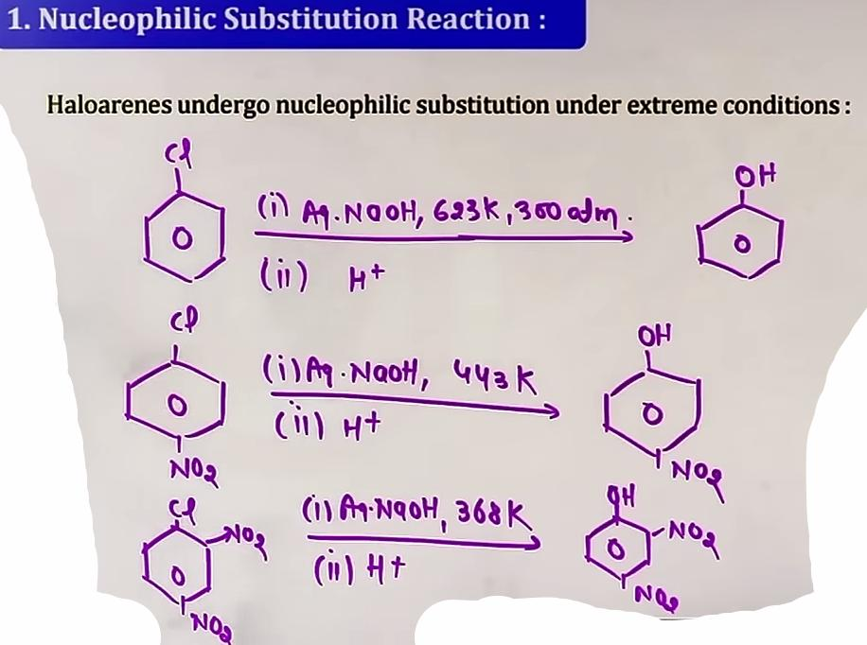
NSR Under Extreme Conditions (Dow's Process):
Chlorobenzene can be converted to Phenol by reacting it with aqueous NaOH at 623K and 300 atm pressure, followed by acidification.

Effect of Electron Withdrawing Groups (EWG):
The presence of groups like NO2 at ortho and para positions greatly increases the reactivity of haloarenes towards NSR.
- The reaction rate increases with more NO2 groups.
- A nitro group at the meta position has no significant effect on reactivity because it cannot stabilize the negative charge of the intermediate carbanion through resonance.

Mechanism (Addition-Elimination):
The nucleophile (OH-) first adds to form a stabilized carbanion intermediate (Meisenheimer complex), followed by the elimination of the halide ion.

Benzyne Mechanism (Elimination-Addition)(SnEA):
Occurs when using an extremely strong base like KNH2 (Potassium amide) in liquid ammonia.
- Step 1 (Elimination): Removal of an ortho-hydrogen and the halogen to form a Benzyne intermediate.
- Step 2 (Addition): The nucleophile (NH2-) adds back to the Benzyne.
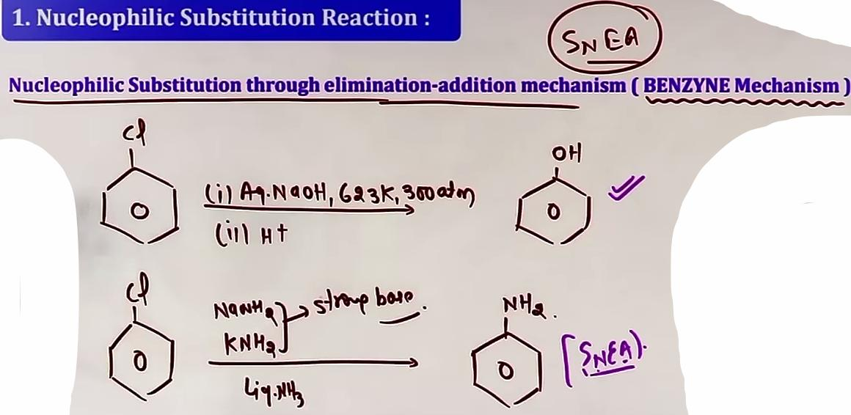
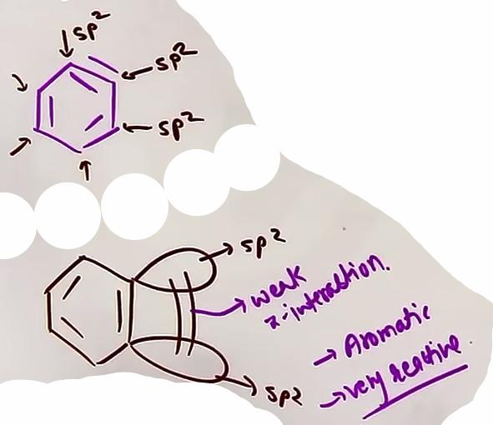
- Benzyne Insight: Despite the "triple bond," the carbons remain sp2 hybridized. The extra bond is formed by the weak sideways overlap of sp2 orbitals.

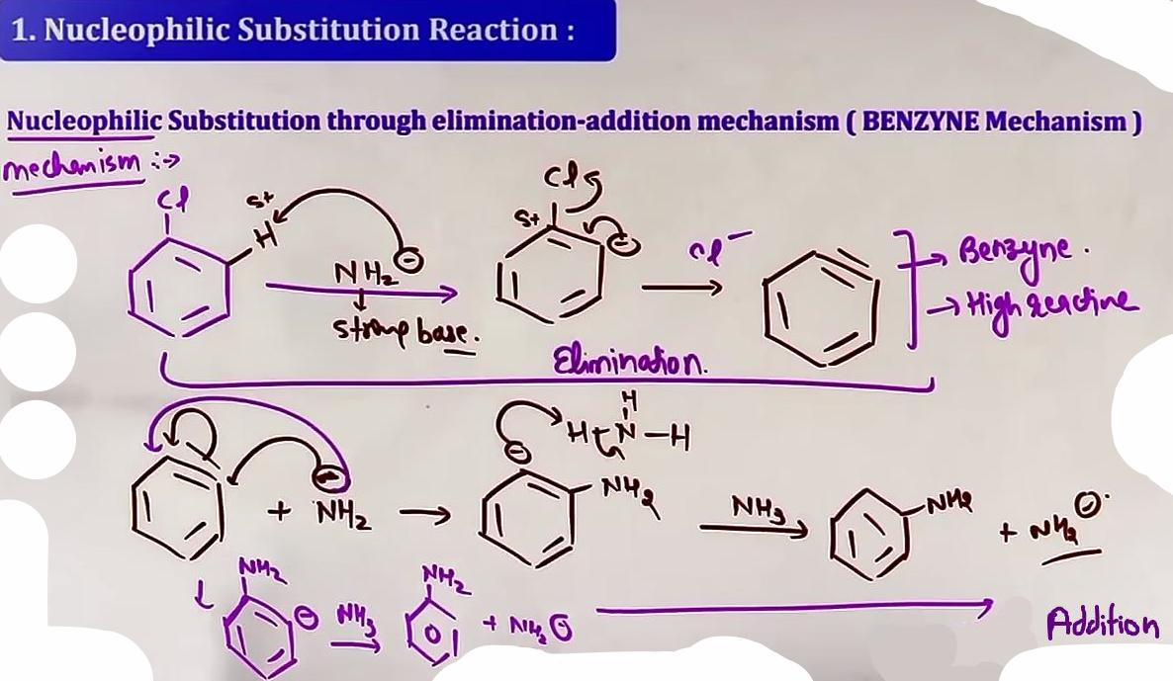

B. ELECTROPHILIC SUBSTITUTION REACTIONS (ESR)

# inki mechanism nahi padhni
Halogens on a benzene ring are Ortho and Para directing but weakly deactivating.
- They are deactivating because of their strong -I (Inductive) effect which withdraws electron density from the ring.
- They are O/P directing because their +M (Resonance) effect increases electron density specifically at the ortho and para positions.

Standard ESR Reactions:
1. Halogenation: Reaction with X2 in the presence of a Lewis acid (FeCl3 or Anhydrous AlCl3). Forms ortho and para dihalobenzenes.
2. Nitration: Reaction with Nitrating Mixture (Conc. HNO3 + Conc. H2SO4). Electrophile: NO2+.
3. Sulphonation: Reaction with Conc. H2SO4 or Oleum (H2S2O7). Electrophile: SO3.
4. Friedel-Crafts Alkylation: Reaction with Alkyl halide (R-X) and Anhydrous AlCl3.
5. Friedel-Crafts Acylation: Reaction with Acyl halide (R-COCl) and Anhydrous AlCl3.
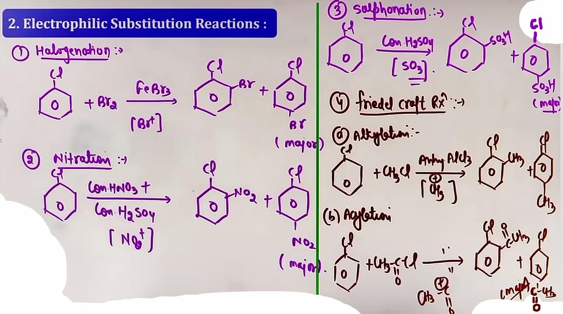ESR reactions
Note: In all cases, the para-isomer is usually the major product due to less steric hindrance.

COMMON MISTAKES AND TRAPS
Mistake | Why Students Make It | Correct Approach / Thinking
NSR on Meta-Nitro | Assuming all EWG help | Resonance only stabilizes Ortho/Para; Meta has no NSR rate boost.
Making Benzene in NSR | Confusion with Grignard | NSR replaces X with OH/NH2; Grignard/H2O makes Benzene.
Ignoring Benzyne | Missing KNH2/LiNH3 clue | Strong base + Aryl Halide = Benzyne intermediate.
Treating X as activating | Resonance is visible | Halogens are unique; they direct O/P but are DEACTIVATING due to -I.

HIGH-YIELD REVISION SHEET
Must Remember:
- Halogens are O/P directing but DEACTIVATING for ESR.
- Para-isomer is major in ESR due to symmetry and less hindrance.
- Dow's Process conditions: NaOH, 623K, 300 atm.
- NO2 groups at O/P positions make NSR easy; Meta NO2 does NOT.
- Fittig Reaction makes Biphenyl; Wurtz-Fittig makes Alkyl-Benzene.

Last-Minute Revision Points:
- NSR Mechanism: Addition followed by Elimination (Intermediate is Carbanion).
- Benzyne Mechanism: Elimination followed by Addition (Intermediate is Benzyne).
- Resonance creates partial double bond character, preventing normal NSR.
- Na in dry ether is the reagent for Wurtz/Fittig coupling.
- Order of NSR reactivity: Para-nitro > Ortho-nitro > Chlorobenzene.

--------------------------------------------------------------------------------

OTHERS

DEFINITION Polyhalogen compounds are organic compounds containing more than one halogen atom in their molecule. These are widely used in industry and agriculture as solvents, propellants, and pesticides.
DICHLOROMETHANE (METHYLENE CHLORIDE – CH2Cl2)
Uses: Used as a solvent in paint removers, a propellant in aerosols, and a process solvent in drug manufacturing.
Physiological Effects: Exposure to low levels can cause slight hearing and vision impairment. High levels cause dizziness, nausea, and numbness in fingers and toes.
CHLOROFORM (TRICHLOROMETHANE – CHCl3)
Uses: Solvent for fats and alkaloids. Historically used as an anesthetic, but now primarily used to produce Freon refrigerant R-22.
Oxidation (Phosgene Formation): Chloroform is slowly oxidized by air in the presence of light to form an extremely poisonous gas called Phosgene (Carbonyl Chloride – COCl2).
Storage: To prevent Phosgene formation, it is stored in closed dark-colored bottles, filled completely to exclude air.

CARBON TETRACHLORIDE (TETRACHLOROMETHANE – CCl4)
Uses: Feedstock for chlorofluorocarbons (CFCs), solvent in pharmaceuticals, and general industrial solvent.
Environmental/Health Effects: Causes irregular heartbeat or eye irritation. It rises to the atmosphere and causes ozone layer depletion.

FREONS (CHLOROFLUOROCARBONS – CFCs)
Definition: Chlorofluorocarbon compounds of methane and ethane.
Properties: Extremely stable, unreactive, non-toxic, non-corrosive, and easily liquefiable.
Uses: Used for refrigeration and air conditioning (AC) purposes.
Example: Freon 12 (CCl2F2) is one of the most common freons.

DDT (p,p-DICHLORODIPHENYLTRICHLOROETHANE)
Full Name: Para,para-dichlorodiphenyltrichloroethane.
Synthesis: Prepared by reacting Chloral (CCl3CHO) with two moles of Chlorobenzene in the presence of concentrated H2SO4.
Uses: Highly effective insecticide, especially against mosquitoes spreading malaria.
TEAR GAS (CHLOROPICRIN – CCl3NO2)
Synthesis: Formed by the reaction of Chloroform with concentrated Nitric Acid (HNO3) in the presence of concentrated H2SO4.
Observation: Causes intense irritation and watering of the eyes.

FORMULA SHEET
COMPOUND | FORMULA | KEY USE/PROPERTY
Methylene Chloride | CH2Cl2 | Paint remover, hearing impairment risk.
Chloroform | CHCl3 | Anesthetic, forms Phosgene (COCl2).
Carbon Tetrachloride | CCl4 | Feedstock for CFCs, ozone depletion.
Freon 12 | CCl2F2 | Refrigeration and Air Conditioning.
DDT | (ClC6H4)2CHCCl3 | Insecticide against malaria mosquitoes.
Tear Gas | CCl3NO2 | Eye irritant (Chloropicrin).

JEE ADVANCE INSIGHTS
- PHOSGENE TEST Since Phosgene is deadly, it is important to check for its presence in chloroform. If Phosgene is present, it reacts with added ethanol to form non-toxic diethyl carbonate.
- BONDING IN FREONS Freons like CCl2F2 are used because they are non-flammable. This is due to the very high bond strength of the C-F bond, which is difficult to break even at high temperatures.
HIGH-YIELD REVISION SHEET
MUST REMEMBER
- Chloroform + O2 + Light -> COCl2 (Phosgene).
- DDT is p,p-dichlorodiphenyltrichloroethane.
- Freon 12 is CCl2F2.
- Chloropicrin (CCl3NO2) is Tear Gas.
- CCl4 and Freons cause Ozone Layer Depletion.
LAST-MINUTE REVISION POINTS
- Chloroform bottles are dark and filled to the brim to exclude air and light.
- Methylene chloride (CH2Cl2) is a paint remover.
- DDT was used extensively in WWII to protect soldiers from malaria.
- Freons are highly stable and non-toxic to humans directly, but toxic to the environment via the ozone layer.

---- ----

Insan to galtiyon ka putla hai.

---- ----

